Palestinian Central Bureau of Statistics (PCBS)

On the Eve of International Youth Day, 12/8/2014

On the eve of International Youth Day, the PCBS releases a statistical review on the status of Palestinian youth:

This press release was prepared during the Israeli aggression on Gaza Strip, where there was no available accurate data on the impact of this aggression. This release covered the period before the Israeli aggression. But preliminary estimates of the number of Palestinians martyrs in Gaza Strip indicated 1,911 martyrs among civilians, as 449 children, 243 women. While number of the wounded reached more than 9,861 (3,004 children and 1,907 women), and the number of displaced people up to 9/8/2014 reached half a million.

Youth comprises one third of Palestinian Society
The percentage of Youth represents 30.0% of the total population in Palestine: 38.1% of them are adolescents aged (15-19) years and 61.9% are youth aged (20-29) years. The sex ratio among youth is 104.2 males per 100 females, while the estimated population in Palestine totaled 4.55 million in mid-2014.

Population Pyramid in Palestine, Mid-2014

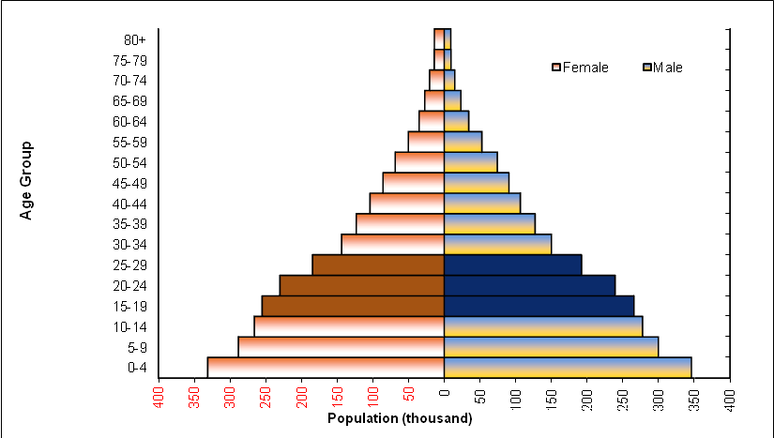

Marriage and divorce rates higher among females aged (15-29)
According to the 2013 database of registered marriages and divorces, 92.2% of females were in the age group of (15-29) years are married compared to 81.0% of males. 77.3% of divorced females were aged between (15-29) years compared with 56.8% for divorced males.

The 2010 data showed that 30.2% of marriages for ever married women (15-29) years were married of first consanguinity linkage to their husbands while 54.9% of marriages had no relative linkage with husbands.

Females aged (25-29) years represent the highest contributor of total fertility rate among all ages groups
According to the final results of the Palestinian Family Survey of 2010, the total fertility rate in Palestine declined to 4.4 births between (2008-2009) compared to 4.6 births in 2006. At the region level, the total fertility rate in the West Bank between (2008-2009) was 4.0 birth compared with 5.2 birth in Gaza Strip. Females aged (25-29) years contribute 26.0% of the total fertility rate, the highest contributor of all age groups.

Age-Specific Fertility Rates by Region, 2008-2009
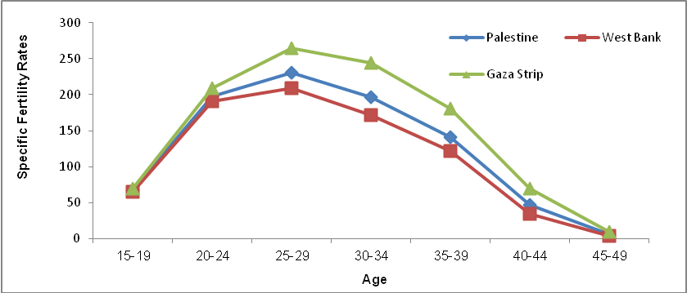

41.6% of youth (15-29) years were enrolled in education in 2013
In 2013, 41.6% of youth aged (15-29) years were enrolled in education; 83.6% in the age group of (15-17) years, 47.4% in the age group of (18-22) years, and 11.2% in the age group of (23-29) years. Dropout rates (who left the education before complete the educational stage who attended) were 31.6%; 37.1% for males and 25.9% for females.

Young female more enrollment at higher education than young males
In addition, 8.9% of males aged (15-29) years hold a university degree compared to 12.2% of females in the same age group. A further 3.0% of males had not completed any educational stage compared to 1.5% of females in the age group of (15-29) years. Furthermore, 0.7% of youth aged (15-29) years are illiterate; 0.6% males and 0.7% females.

Almost half of youth do not read newspapers and magazines
In 2010, 49.9% of youth aged (15-29) years in Palestine do not read newspapers or magazines at all; 40.4% in the West Bank and 65.3% in Gaza Strip. Also, 87.4% of youth in Palestine watch television on a daily basis compared to 27.4% who listen to the radio daily, while 25.0% of youth use the Internet.

The majority of youth use the Computer
Data on information technology during previous years indicated that there had been a remarkable development in indicators regarding access and the use of information and communication technology among young people in the age group of (15-29) years. The data reported in 2011 showed that the proportion of young people who use the computer was 67.5% in Palestine (70.4% in the West Bank and 62.7% in Gaza Strip), compared with 47.6% in 2004. The gap among both sexes in using of computers narrowed to 69.8% among males compared to 65.0% among females in 2011.

43.0% of youth use e-mail
42.9% of youth in Palestine have an e-mail address (51.1% of males against 34.4% of females), as 45.9% in the West Bank and 38.2% in Gaza Strip in 2011.
Three-quarters of youth use a mobile phone
In 2011, the percentage of young people who owned a mobile phone rose to 75.2% in Palestine, this rate varied significantly by gender at 86.3% among males against 63.7% among females in 2011, While 79.4% in the West Bank against 68.5% in Gaza Strip.

The majority of youth evaluated their health as good
83.9% of youth aged (15-29) years evaluated their health conditions as good; 86.2% of males against 80.6% of females, while reached 80.8% in the West Bank against 89.3% in Gaza Strip. Sport activities were being exercised regularly by 33.5% of youth; 35.6% in the West Bank and 30.1% in Gaza Strip.

About three in every 100 youth suffered from one chronic disease at least
In Palestine, 2.5% of youth aged (15-29) years reported that they suffered from at least one chronic disease; 2.8% of males and 2.1% of females.

Prevalence of chronic diseases among youth aged (15-29) years

by sex and region, 2010

Sex | Palestine | West Bank | Gaza Strip
Both sexes | 2.5 | 2.7 | 2.2
Males | 2.8 | 3.0 | 2.4
Females | 2.1 | 2.3 | 1.9

More than one quarter of Male youth smoke
In Palestine, 15.1% of youth in the age group of (15-29) years reported that they smoke; 28.7% male and 0.9% female.

Prevalence of smoking among youth aged (15-29) years

by sex and region, 2010

Sex | Palestine | West Bank | Gaza Strip
Both sexes | 15.1 | 19.8 | 7.3
Males | 28.7 | 37.4 | 14.3
Females | 0.9 | 1.4 | 0.1

About 4 in every 10 of youth unemployed during the second quarter 2014
The data of labor force survey for the second quarter of 2014 showed that 39.7% of youth aged (15-29) years are economically active (employed and unemployed); 40.6% in the West Bank and 38.3% in Gaza Strip. The youth unemployment rate totaled in Palestine at 39.5%. The highest unemployment rate was 43.1% in the age group of (20-24) years compared with 36.6% for the age group of (25-29) years. In addition, 41.1% of those unemployed had completed at least 13 schooling.

Knowing that rate of unemployment is expected to double in Gaza Strip during Israeli aggression to reach record levels.

Half of youth graduates are unemployed
The unemployment rate among youth graduates was 55.5% in the second quarter of 2014. The highest unemployment rate was 71.2% for graduates in education and teacher training, while the lowest unemployment rate of 9.9% was among law graduates.

22.6% of youth have completed the transition from education to the labor market.
In 2013, the survey of transition of youth from education to the labor market results showed that 22.6% of youth people aged (15-29) years have completed the transition from education to the labor market to work in stable jobs and permanent, while 77.4% of young people have moved out of the labor force, or unemployed, or to the work of non-permanent temporary lasting less than 12 month

More than a quarter of youth in Palestine suffered from poverty during the year of 2011
The relative poverty line and the deep poverty line according to consumption patterns (for reference household consisted of 2 adults and 3 children) in Palestine in 2011 were 2,293 NIS, and 1,832 NIS respectively. The poverty rate among Palestinian individuals was 25.8 (17.8% in the West Bank, and 38.8% in Gaza Strip). 12.9% of the individuals in Palestine were suffering from deep poverty in 2011 according to consumption patterns (7.8% in the West Bank, and 21.1% in Gaza Strip). While 27.4% of youth (15-29) years are under the poverty rate (19.2% in the West Bank and 40.9% in Gaza Strip.

Females more vulnerable to violence
Data of the violence survey in Palestinian society 2011 indicated that 20.8% of the youth were vulnerable to one type of violence at the least (19.4% for males against 22.1% for females).

31.4% of the youth who were vulnerable to psychiatric violence, and 39.1% were vulnerable to physical violence while 1.1% of them were vulnerable to sexual violence.

