Establishment Census 2012

Preliminary results of the census

The preliminary results of the Establishment census represent all establishments in the Palestinian Territory which have been enumerated during the period 03/09/2012- 24/10/2012, the number of establishments in the Palestinian Territory were 150,361 including 101,816 establishments in the West Bank and 48,545 establishments in Gaza Strip.

Hebron Governorate occupied the first place in numbers of establishments.

The results showed that Hebron Governorate came in first place among the governorates in terms of the number of establishments by 21,747 establishment followed by the governorates of Gaza and Nablus by 19,563 and 16.563 respectively. While the governorates of Tubas, Salfit, and the Jericho and Al Aghwar governorate got the lowest number of establishments by 1,764 and 2,730 and 1,688 respectively.

96.4% of the establishments in the Palestinian Territory were operating.

It should be noted that the distribution of actively operating establishments in the Palestinian Territory during the census amounted to 144,964 while 4,140 establishments were not operating(inactive) and 1,257 were under construction The number of operating establishments in the West Bank was 98,384 as 2,623 of them were not operating (closed) and 809 establishments were under construction. In Gaza Strip, there were 46,580 operating establishment while 1,517 establishments were not operating (closed ), and 448 establishments were under construction.

Percentage distribution of Establishments in the Palestinian Territory by Establishment
Status, 2012

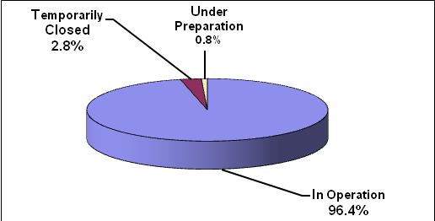

At the geographical distribution, it should be noted that concentration of operating establishments at the governorate level of the largest number of operating establishments in the West Bank was in Hebron, which represented 21.6% of the total number of establishments in West Bank, Nablus came in second place with 16.1% , while Ramallah and Al-Bireh had 14.0% of them.
The Jericho and Al Aghwar governorate got the lowest number of establishments by 1.5% .
In Gaza Strip, results showed that the concentration of operating establishments were mainly in the governorate of Gaza and constituted 40.4% of the total number of establishments in Gaza Strip, followed by Khan Yunis governorate by 18.5%, while Rafah governorate got the lowest number of establishments by 11.8% of the total number of establishments in Gaza Strip.

Number of Establishments in the Palestinian Territory by Governorate, 2012

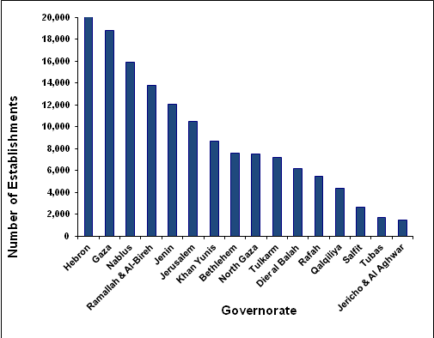

Gaza Governorate ranked at first place in number of employees by 15.1%

Preliminary results of the establishment census 2012 indicated that the number of employees in the private sector, non governmental organization sector and government companies was 387,341 in the Palestinian Territory as 265,105 employees were in the West Bank by 68.4% of the total employees in Palestinian Territory, and 122,236 in Gaza Strip by 31.6% of the total employees in the Palestinian Territory. Male employees constituted 81.9% of total employees in Palestinian Territory compared to 18.1% for females. The distribution of employees in the private sector, non governmental organization sector and government companies in the Palestinian Territory by Governorate, results showed that Gaza governorate was ranked at first place, where number of employees reached 58,447 by 15.1% of the total employees in the Palestinian Territory followed by Ramallah and Al-Bireh at 54,256 by 14.0%, while Tubas got the lowest number of employees at 3,153 by 0.8% of the total employees in the operating establishments in Palestinian Territory.

An increase by 27.6 % in number of operating establishments in 2012 compared to 2007

The number of operating establishments in 2012 (excluding J1) 139,494 with an increase by 27.6% compared to 2007, an increase by 42.7% compared by 2004 and by 79.4% compared with 1997, as their number reached 109,355 operating establishments in the Establishments Census of 2007 constituting 89.5% of the total establishments in 2007 in Palestinian Territory, while in establishments census of 2004 , there was 97,848 operating establishments and formed 87.9% of the total establishments in 2004. The establishments Census of 1997, the establishments number totaled 77,760 which constituted 87.2% of the total establishments in 1997.
The total number of employees in operating establishments of private, civil and governmental companies in the Palestinian Territory reached 368,295 (excluding Jerusalem JI) in 2012 with an increase by 30.4% compared to 2007 and with an increase by 50.1% compared to 2004 and by an increase of 102.1 % compared to 1997.

20,142 establishments were closed in the Palestinian Territory.

Preliminary results showed that the number of not operating (closed) establishments in the Palestinian Territory reached 20,142 establishments as 16,918 of them were in the West Bank, while 3,224 closed establishments were in Gaza Strip.

Table 1: Number of Establishments in the Palestinian Territory by Region and Establishment Status, 2012

Region | Establishment Status |  |  | Total
Region | In Operation | Temporarily Closed | Under Preparation | Total
Palestinian Territory | 144,964 | 4,140 | 1,257 | 150,361
West Bank | 98,384 | 2,623 | 809 | 101,816
Gaza Strip | 46,580 | 1,517 | 448 | 48,545
Note: Number of closed establishment was 20,142 in 2012

Table2: Number of Establishments in Operation,
Number of Employed Persons in the Private Sector, Non Governmental Organization Sector and Government Companies in the Palestinian Territory by Governorate, 2012

Governorate | Number of Establishments in Operation | Number of Employed Persons
Palestinian Territory | 144,964 | 387,341
West Bank | 98,384 | 265,105
Jenin | 12,077 | 24,820
Tubas | 1,678 | 3,153
Tulkarm | 7,175 | 15,692
Nablus | 15,872 | 42,613
Qalqiliya | 4,332 | 9,039
Salfit | 2,625 | 5,630
Ramallah & Al-Bireh | 13,801 | 54,256
Jericho & Al Aghwar | 1,481 | 4,298
Jerusalem | 10,453 | 31,819
Bethlehem | 7,614 | 23,213
Hebron | 21,276 | 50,572
Gaza Strip | 46,580 | 122,236
North Gaza | 7,503 | 19,318
Gaza | 18,807 | 58,447
Dier al Balah | 6,158 | 14,363
Khan Yunis | 8,635 | 18,630
Rafah | 5,477 | 11,478

Table3: Number of Employed Persons in the Private Sector, Non Governmental Organization Sector and Government Companies in the Palestinian Territory by Governorate, 2012

Governorate | Number of Employed Persons |  | Total
Governorate | Males | Females | Total
Palestinian Territory | 301,507 | 66,788 | 368,295
West Bank | 195,784 | 50,275 | 246,059
Jenin | 19,833 | 4,987 | 24,820
Tubas | 2,473 | 680 | 3,153
Tulkarm | 12,259 | 3,433 | 15,692
Nablus | 34,492 | 8,121 | 42,613
Qalqiliya | 6,955 | 2,084 | 9,039
Salfit | 4,165 | 1,465 | 5,630
Ramallah & Al-Bireh | 41,421 | 12,835 | 54,256
Jericho & Al Aghwar | 3,342 | 956 | 4,298
Jerusalem | 10,432 | 2,341 | 12,773
Bethlehem | 17,897 | 5,316 | 23,213
Hebron | 42,515 | 8,057 | 50,572
Gaza Strip | 105,723 | 16,513 | 122,236
North Gaza | 16,459 | 2,859 | 19,318
Gaza | 50,840 | 7,607 | 58,447
Dier al Balah | 12,418 | 1,945 | 14,363
Khan Yunis | 16,079 | 2,551 | 18,630
Rafah | 9,927 | 1,551 | 11,478
Note: Dose not include those parts of Jerusalem which were annexed by Israel in 1967.

