Palestinian Central Bureau of Statistics (PCBS)

The Results of the Economic Surveys Series,2013

There are 122,057 private and non-governmental enterprises excluding agriculture operating in economic activities in Palestine

The survey result show that 122,057 private, non-governmental excluding agricultural enterprises were in operation in the following economic activities in Palestine. internal trade 57.4%, services 27.7%, industrial activities 13.3%, transportation and storage 0.7%, information and communications 0.5% and construction 0.4%.

62.5% of employed persons were waged employees.

During 2013, 386,794 workers were employed in these economic activities as follows: internal trade 39.5%, services 33.5%, industrial activities 20.6%, construction 2.6%, information and communications 2.1% and transportation and storage 1.7%.

The output value of enterprises in Palestine was USD 10,587.5 million distributed by economic activity as follows: industrial activities 38.0%, internal trade 27.7%, services 17.9%, information and communications 8.5%, construction 6.3% and transportation and storage 1.6%.

The gross value added in Palestine was USD 6,453.5 million distributed by economic activity as follows: internal trade 35.8%, industrial activities 25.2%, services 21.8%, information and communications 11.4%, construction 4.3% and transportation and storage 1.5%.

Percentage Distribution of Value Added for Operating Enterprises in Private and Non-Governmental Organization Sectors in Palestine by Main Economic Activity, 2013

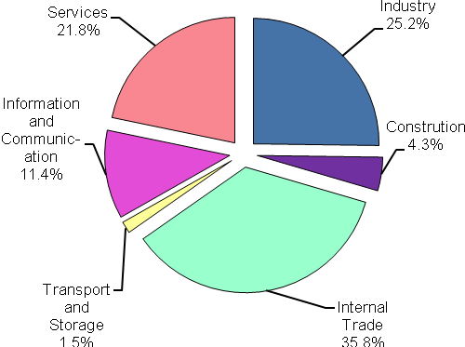

Data collection of Economic Surveys Series were funded by the European Union.

