Palestinian Central Bureau of Statistics (PCBS)

Press Release on Results of Domestic and Outbound Tourism, 2014

Highest Number of Domestic Trips in the Gaza Strip

In Palestine, 36.9% of households (at least one Household member) participated in a domestic trip during 2014: 32.5% of them in the West Bank compared to 45.5% in Gaza Strip.
Of households participating in domestic trips, 43.3% made one trip, 26.2% made two trips, and 30.5% participated in three trips or more.
Percentage Distribution of Households in Palestine whom Conducted Domestic Trips, by Number of Trips and Region, 2014
Region | No. of Trips |  |  | Total
Region | 1 | 2 | +3 | Total
Palestine | 43.3 | 26.2 | 30.5 | 100
West Bank | 47.7 | 23.6 | 28.7 | 100
Gaza Strip | 37.3 | 29.6 | 33.1 | 100

The most visited location in the West Bank was Mega Fun Land in Tulkarm governorate with 21.8% of visitors, followed by Albathan Valley in Nablus governorate with 16.8%. In Gaza Strip, Alnoor city and Gaza beach were the most visited each with 21.0%, 20.6% respectively while the North Gaza beach accounted for 14.2% of travelers.
The average household expenditure during domestic trips was USD 61.2: USD 86.6 in the West Bank compared to USD 26.5 in Gaza Strip.
Almost one fifth of Palestinian households in the West Bank participated in outbound trips during 2014.
Survey results indicate that 16.1% of households (one member at least) traveled outside Palestine during 2014: 21.6% of West Bank households compared to only 5.5% of households in Gaza Strip.
Percentage Distribution of the Households by Conducted of Outbound Trips and Region, 2014

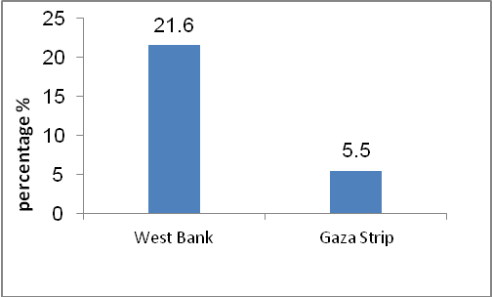
Jordan Main Destination for Outbound Trips
In trips abroad by households in Palestine, 45.0% travelled to Jordan, 23.0% to Saudi Arabia, 12.4% to Israel and 6.5% to Egypt, In addition, 2.8% of households visited Turkey.
Visiting Relatives and/or Friends of the Main Purposes of Outbound Trips
Survey results reveal that 35.8% of traveled households in Palestine visited relatives and/or friends, and 22.9% travelled for religious purposes, 19.1% of them traveled abroad for leisure and 5.8% travelled for business or work purposes.
For the organization of trips, 62.5% of households organized outbound trips themselves, and 29.2% used the services of a travel agent.
Average household expenditure during an outbound trip was USD 1,224.9 of which USD 314.1 were spent on shopping and USD 212.8 spent on Transp and USD 176.7 on Travel Agencies.

