Palestinian Central Bureau of Statistics (PCBS)

- Around 113,000 of Individuals in the Palestinian Territory Suffered from at Least One Disability in 2011
- Mobility is Most Common Disability

Prevalence of disability in the Palestinian Territory
Prevalence among males is higher than females,
Around 113,000 of individuals suffered from at least one disability, formed 2.7% of population in the Palestinian Territory, 75,000 in the West Bank; 2.9%, and around 38,000 in Gaza Strip; 2.4%. while it was 2.9% for males and 2.5% for females.

Percentage of Disabled Individuals, 2011 ‏
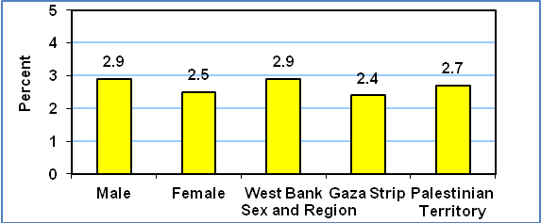

Prevalence of Disability Increase with Age:
The prevalence of disability is strongly correlated with age. Disability rates are significantly higher among individuals aged 75 and above at 32.0%; 28.9% of males and 34.1% among females. Among children, the percentage was 1.5%; 1.8% among males and 1.3% among females.

With regard to the prevalence of disability according to region and age, 31.4% of individuals aged 75 and above were in the West Bank and 33.6% were in Gaza Strip. Among children 0-17 years, the rates were 1.6% in the West Bank and 1.4% in Gaza Strip.

Highest Percentage of Disabilities in Jenin Governorate, Lowest in Jerusalem:
In Jenin governorate, 4.1% of individuals have a disability, followed by Hebron governorate with 3.6%, while 1.4% in Jerusalem. In Gaza Strip, the highest prevalence was reported in Gaza governorate with 2.5%, followed by North Gaza, Rafah and Deir Al Balah governorates with 2.4% each. The lowest prevalence was in Khan Yunis governorate; 2.2%.

Mobility is Most Common Disability:
Mobility is the disability with the highest prevalence comprising 48.4% of disabled individuals in the Palestinian Territory: 49.5% in the West Bank compared to 47.2% in Gaza Strip. Learning disability is second with 24.7%: 23.6% in the West Bank and 26.9% in Gaza Strip

Illness is main cause of disabilities:
Illness is the main cause of all disabilities that are covered in the survey. Illness was the main cause of 43.7% of Seeing disabilities; 29.1% of hearing disabilities, 42.9% of mobility disabilities; 28.7% of disabilities relating to Remembering and Concentrating, 27.6% of learning disabilities; and 27.2% of mental disabilities. Congenital problems were the main cause of communication disabilities with 33.6%.

Impact of Environmental and Physical Obstacles on Live of Disabled Individuals
8.7% of disabled individuals aged 18 years and above in the Palestinian Territory usually avoid involvement in any activities because of public attitudes towards them: 9.5% in the West Bank and 7.7% in Gaza Strip.
76.4% of disabled individuals aged 18 years and above in the Palestinian Territory do not use public transportation due to the absence of necessary adaptations in the infrastructure; 75.5% in the West Bank and 78.1% in Gaza Strip.
34.2% of disabled individuals aged 18 years and above in the Palestinian Territory stated that they were unable to perform daily activities outside their homes due to their disability: 32.1% in the West Bank and 38.4% in Gaza Strip.

More than one-fifth of disabled dropped out of school due to the environmental and physical obstacles:
22.2% of disabled individuals aged 18 years and above in the Palestinian Territory dropped out of school due to the environmental and physical obstacles: 23.2% in the West Bank and 19.4% in Gaza Strip. Of these, 21.7% are male and 22.9% female.

Difficulties Performing Activities Outside Home Due to Surrounding Infrastructure
54.7% have difficulty due to problems with not adequate pavements; 60.4% have difficulty crossing streets; 40.3% have difficulty in walking and crossing the streets due to the size of the road signs.

In addition, 42.9% of disabled individuals face difficulty due to the fact that recreation services are not available to them and 48.4% find problems with parking.

