Palestinian Central Bureau of Statistics (PCBS)

- 2.7% of Individuals in Palestine Suffered from at Least One Disability in 2011
- Mobility is Most Common Disability in Palestine

International Day of Persons with Disabilities on December 3rd is an international observance promoted by the United Nations since 1992. The observance of the Day aims to promote an understanding of disability issues and mobilize support for the dignity, rights and well-being of persons with disabilities. It also seeks to increase awareness of gains to be derived from the integration of persons with disabilities in every aspect of political, social, economic and cultural life. The theme this year is " Inclusion matters: access and empowerment of people of all abilities.

Prevalence of Disability in Palestine
In 2011 data shows that around 113 thousand individuals suffer from at least one disability and constitute 2.7% of the population in Palestine: 75 thousand in the West Bank 2.9%, and around 38 thousand in the Gaza Strip 2.4%. By gender, 2.9% are males and 2.5% are females.

Percentage of Disabled Individuals by Sex and Region, 2011 ‏
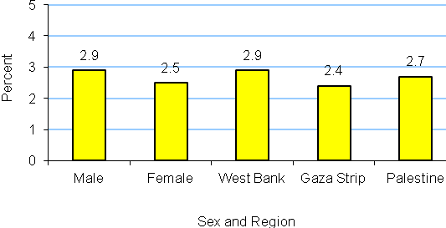
Mobility is Most Common Disability, 2011
Mobility is the most prevalent disability and affects 48.4% of disabled individuals in Palestine: 49.5% in the West Bank compared with 47.2% in the Gaza Strip. Learning disability is the second most prevalent with 24.7%: 23.6% in the West Bank and 26.7% in the Gaza Strip.

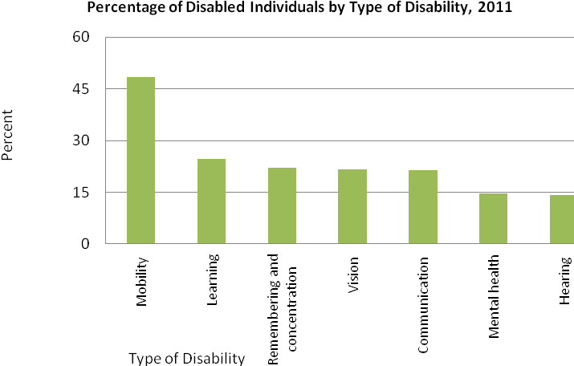
The right to learn
37.6% of all disabled individuals aged 15 years and above in Palestine had never been enrolled at school; 35.5% in the West Bank and 42.2% in Gaza Strip. In addition, 33.8% of all disabled individuals had dropped out of school; 37.0% in the West Bank and 27.1% in Gaza Strip. Illiteracy rates were 53.1% of all disabled individuals; 51.5% in the West Bank and 56.3% in Gaza Strip. Also the ministry data shows that the number disabled children who are integrated into formal education in the age 6-17 years reached 8,032 students in the year 2011. However, the total disabled children in the age 6-17 years old is 23,825 children.

Accessibility and Adaptations for Student with Disabilities in Schools
54.6% of schools in the West Bank and Gaza Strip have adaptations for students with disabilities in terms of appropriate toilets and 44.0% have ramps. More public and UNRWA schools than private schools have these adaptations. Although half of the schools have appropriate toilets and ramps for student with motor disabilities, there are other types of disabilities that require special adaptations that are not available in schools. These include special transportation and classroom accessibility.

