Palestinian Central Bureau of Statistics (PCBS)
Palestinian Culture Day 2015

On the eve of the Palestinian Culture Day, 13th March 2015, the Palestinian Central Bureau of Statistics – following statistical review on culture of households and persons based on the Culture Survey Findings for 2014, presents the results as follows:

Real Stories are the Most Traditional Cultural Themes Discussed in Palestinian Households
87.5% of households in Palestine recount stories about real life and 68.0% tell folk stories. In addition, 66.1% of households narrate sayings and proverbs, while 64.6% discuss political issues, 53.9% tell jokes, 52.8% bring up puzzles and riddles, and 46.0% discuss myths while 37.0% dialogue about poetry and folk songs.

3 out of 10 households in Palestine have a home library
The average national percentage of households with a home library was 27.0% distributed as 26.6% of households of the West Bank and 27.7% of households Gaza Strip. The figure for Palestine as a whole in 2009 was 20.3%.

About One Fifth of Palestinian Households Obtain a Daily Newspaper
The percentage of households in Palestine who obtain a daily newspaper was 20.4% distributed as 23.7% in the West Bank and 14.1% in Gaza Strip. compared with 32.1% in 2009.
Also, 22.6% of persons aged 10 years and above in the Palestinian society read newspapers: 26.9% of males and 18.2% of females.

More than Half of Palestinian Households Prefer to Listen to News
The percentage of households who listen to radio stations was 60.8%, including 57.3% in the West Bank and 67.6% in Gaza strip. With regard to the household’ first choice program to listen, news ranked the highest followed by religious programs and music and song.

Percentage Distribution of Households Who Listen to Radio Station by Preferred Type of Program, 2014

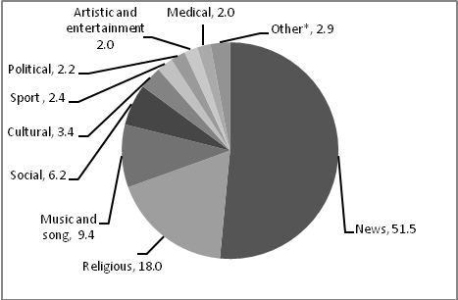
*Other includes programs: children, documentaries, educational, scientific and environmental, heritage and economic.

Also, the percentage of persons aged 10 years and above who listen to the radio in Palestine was 49.2% distributed as 51.5% of males and 46.8% of females.

A Noticeable Rise in Percentage of Listeners to the Voice of Palestine in 2014 compared with 2009
The percentage of persons aged 10 years and abov e who listen to the Voice of Palestine increased to 54.9% compared to 27.8% in 2009.

About Four out of every 10 Households with a TV Set Watch Palestine TV on a Daily Basis
17.2% of households who have a TV set watch local television stations. Data also showed that 39.1% of households with a TV set watch Palestine TV on a daily basis: 44.1% for the West Bank and 29.3% for Gaza Strip. In comparison with 2009 this percentage was 25.3%.

Watching Television and Video is the Most Practiced Activity during Free Time
63.8% of persons aged 10 years or more watched television and video in their free time (59.6% of males and 68.2% of females); 11.3% used the computer or internet (13.2% of males and 9.3% of females); 7.2% met with friends and relations (8.1% of males and 6.4% of females); 5.8% practiced sports (9.8% of males and 1.7% of females); and 5.3% read newspapers, books and magazines (4.2% of males and 6.5% of females) and 6.6% performed other different activities.

Sporting Activity is the Most Practiced Activity in the Educational Institutions
With regard to practicing activities at school or university during scholastic year 2013\2014, Data revealed that 44.9% of persons aged 10 years and above participated in sporting activities, 35.5% were engaged in academic and technological activities, and 35.0% memorized the Quran. Also, 11.3% of persons practiced Dabkeh (Palestinian folk dance), 10.9% took theater and drama, and 6.1% were engaged in individual singing, choir and playing music.

Disparity in Percentages of Membership to Public Institutions between Males and Females
Data showed that 7.1% of persons aged 10 years and above are members of sports clubs, 4.6% are members of charitable societies, and 3.9% are members of unions. In addition, 3.4% of persons are affiliated to political parties, 1.3% are members of youth movements. There is a significant difference between males and females in this regard.

Percentage of Persons (10 Years and Above Who are Members in Public Institutions by Type of Public Institutions and Sex, 2014

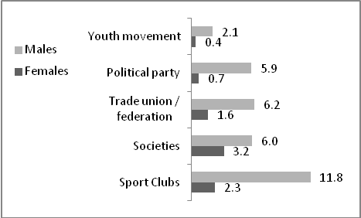
Percentage of Persons who Listen to Music in the West Bank is High Compared with Gaza Strip
The percentage of persons aged 10 years and above who listen to music was 59.3% distributed as 60.5% of males and 58.2% of females. There is a significant difference between the West Bank and Gaza Strip in this regard: 71.2% in the West Bank and 39.2% in Gaza Strip.

18.5% of Households in Palestine Have Members who Wear Traditional Palestinian Dress
About 19 out of 100 households in Palestine have members who wear traditional Palestinian dress. There is a significant difference between the West Bank and Gaza Strip in this regard, as shown in the diagram here below.

Percentage of Households Who have Members who Wear Traditional Palestinian Dress by Region, 2014

