State of Palestine

Palestinian Central Bureau of Statistics

Palestinian Consumer Price Index, February, 02/ 2013

Decreasing in the CPI during February 2013 compared with previous month
The overall Consumer Price Index (CPI) for Palestine during February 2013 decreased by 0.47% compared with January 2013 (decreased by 0.76% in the West Bank, and by 0.51% in Jerusalem J1*, and by 0.41% in Gaza Strip).

The CPI during February 2013 increased by 1.76% compared with February 2012 (2.75% in the West Bank, 1.77% in Jerusalem J1*, 0.27% in Gaza Strip).

The change in Consumer Price Index (CPI) for February 2013 is traced back to changes in prices of the following expenditure sub groups compared to the previous month:

Sub Groups | %Change
Fresh vegetables | - 9.54%
Potatoes and other tubers | - 9.08%
Sugar | - 3.41%
Eggs | + 15.04%
Gas | + 7.30%
Fuel for transportation | + 2.66%
Fresh poultry | + 2.29%

The trend line for the consumer price index in Palestine for 2004 – 2012

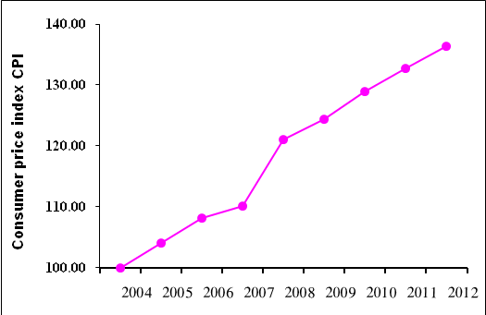

Note:
* Jerusalem J1: those parts of Jerusalem which were annexed by Israel in 1967
The data of West Bank doesn't cover Jerusalem J1.

