Palestinian Central Bureau of Statistics (PCBS)

Palestinian Consumer Price Index during 2014

Increase in the CPI during 2014 compared with the previous year

The overall Consumer Price Index (CPI) for Palestine during 2014 increased by 1.73% compared with 2013 (increased by 3.84% in Jerusalem J1*, 2.85% in Gaza Strip, and by 1.20% in the West Bank).

The change in Consumer Price Index (CPI) for 2014 is traced back to changes in prices of the following expenditure sub groups compared to the previous year:

Sub Groups | %Change
Cigarettes | + 10.72%
Fresh Fruit | + 5.96%
Fresh Vegetables | + 4.44%
Eggs | + 4.15%
Liquid Fuel for House | + 2.08%
Potatoes and other Tubers | - 20.35%
Dried Vegetables | - 19.14%
Fresh Meat | - 6.28%
Flour | - 5.20%
Fresh Poultry | - 1.21%

The trend line for the consumer price index in Palestine for January – December 2014
(Base Year 2010=100)

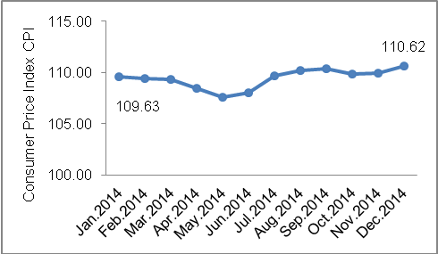

The trend line for the consumer price index in Palestine for 2004 – 2014
(Base Year 2010=100)

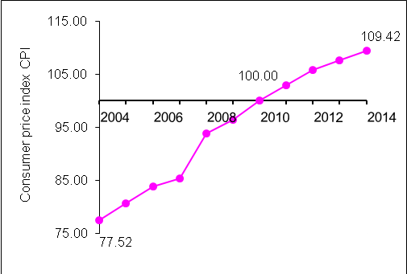

Note:
* Jerusalem J1: those parts of Jerusalem which were annexed by Israel in 1967
The data of West Bank doesn't cover Jerusalem J1.

Data collection of Consumer Price Index survey was funded by the European Union.

