Palestinian Central Bureau of Statistics (PCBS)

Palestinian Consumer Price Index, 2013

CPI: A significant increase in the West Bank against a decrease in Gaza Strip during 2013 compared with the previous year
The overall Consumer Price Index (CPI) for Palestine during 2013 increased by 1.72% compared with 2012 (increased by 3.10% in the West Bank, and by 1.81% in Jerusalem J1*, while it decreased by 0.76% in Gaza Strip).

The change in Consumer Price Index (CPI) for 2013 is traced back to changes in prices of the following expenditure sub groups compared to the previous year:

Sub Groups | %Change
Potatoes and other tubers | + 43.57%
Dried Vegetables | + 31.89%
Cigarettes | + 12.49%
Eggs | + 16.25%
Education | + 6.95%
Gas | + 6.51%
Fresh Poultry | + 3.09%
Electricity | + 3.04%
Medical Care | + 1.70%
Sugar | -11.99%
Liquid Fuel for House | - 9.11%
Rice | - 5.99%
Liquid Fuel for Cars | - 2.71%
Fresh Fruit | -1.25%
Fresh Vegetables | -0.96%

The trend line for the consumer price index in Palestine for January – December 2013
(Base Year 2004=100)

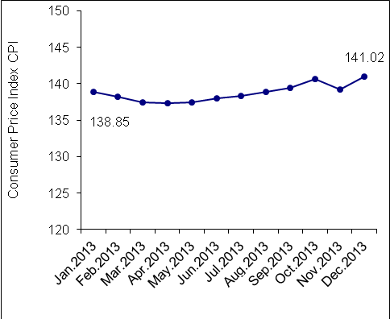

The trend line for the consumer price index in Palestine for 2004 – 2013
(Base Year 2004=100)

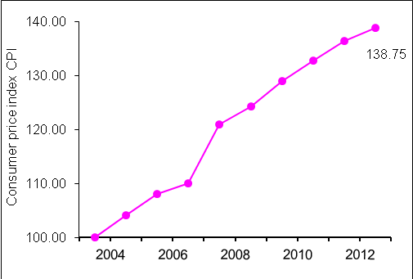

Note:
* Jerusalem J1: those parts of Jerusalem which were annexed by Israel in 1967
The data of West Bank doesn't cover Jerusalem J1.

Data collection of Consumer Price Index survey was funded by the European Union.

