Palestinian Central Bureau of Statistics (PCBS)

Palestinian Consumer Price Index, 2012

Increase in the CPI During 2012

The overall Consumer Price Index (CPI) for the Palestinian Territory during 2012 increased by 2.78% compared with 2011 (4.08% in the West Bank, 3.23% in Jerusalem J1*, 0.48% in Gaza Strip).

The change in Consumer Price Index (CPI) for 2012 is traced back to changes in prices of the following expenditure sub groups compared to the previous year:

Sub Groups | %Change
Fresh vegetables | + 15.03%
Fresh poultry | + 8.91%
Cigarettes | + 7.42%
Fuel for transportation | + 5.81%
Education | + 5.47%
Fuel and electricity | + 3.67%
Medical care | + 3.06%
Fresh fruit | + 2.17%

The trend line for the consumer price index in the Palestinian Territory for 2004 – 2012

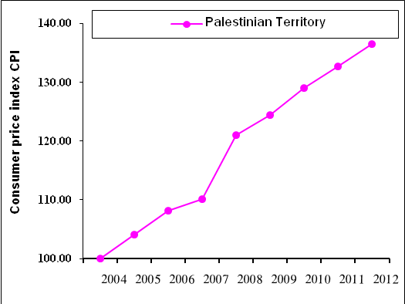

Note:
* Jerusalem J1: those parts of Jerusalem which were annexed by Israel in 1967
The data of West Bank doesn't cover Jerusalem J1.

