Palestinian Central Bureau of Statistics (PCBS)

Palestinian Consumer Price Index, December, 12/2012

Stability in the CPI during December 2012 compared with previous month
The overall Consumer Price Index (CPI) for the Palestinian Territory during December 2012 decreased by 0.01% compared with November 2012 (decreased by 0.25% in the Jerusalem J1*, while it increased by 1.27% in Gaza Strip, and by 0.02% in the West Bank).

The CPI during December 2012 increased by 1.72% compared with December 2011 (2.71% in the West Bank, 3.15% in Jerusalem J1*, 0.55% in Gaza Strip).

The change in Consumer Price Index (CPI) for December 2012 is traced back to changes in prices of the following expenditure sub groups compared to the previous month:

Sub Groups | %Change
Fresh vegetables | - 6.24%
Fresh fruit | - 1.40%
Fuel for transportation | - 0.55%

The trend line for the consumer price index in the Palestinian Territory for 2004 – 2012

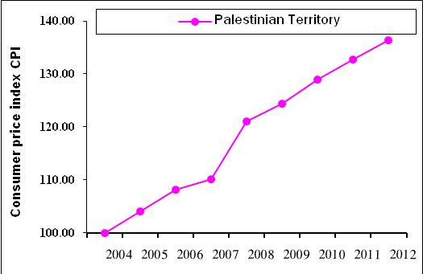

Note:
* Jerusalem J1: those parts of Jerusalem which were annexed by Israel in 1967
The data of West Bank doesn't cover Jerusalem J1.

