Palestinian Central Bureau of Statistics (PCBS)

Palestinian Consumer Price Index, November, 11/2013

Decrease in the CPI during November 2013 compared with previous month
The overall Consumer Price Index (CPI) for Palestine during November 2013 decreased by 0.99% compared with October 2013 (decreased by 2.07% in the West Bank, and by 1.25% in Gaza Strip, and by 0.59% in Jerusalem J1*).

The CPI during November 2013 increased by 1.41% compared with November 2012 (2.70% in the West Bank, and by 1.14% in Jerusalem J1*, while it decreased by 1.08% in Gaza Strip).

The CPI during the first Eleven months of 2013 increased by 1.63% compared with the same period of the previous year (2.98% in the West Bank, 1.71% in Jerusalem J1*, while it decreased by 0.72% in Gaza Strip).

The change in Consumer Price Index (CPI) for November 2013 is traced back to changes in prices of the following expenditure sub groups compared to the previous month:
Sub Groups | %Change
Fresh Vegetables | - 10.81%
Fresh Poultry | - 8.08%
Eggs | - 7.63%
Liquid Fuel for Cars | - 0.55%
Fresh Fruit | + 0.91%
The trend line for the consumer price index in Palestine for 2004 – 2012
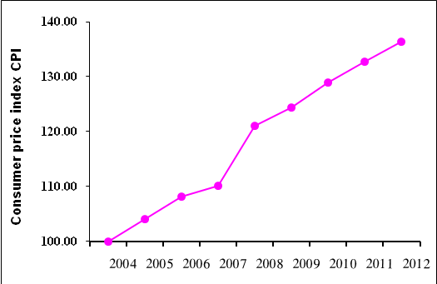

Note:
* Jerusalem J1: those parts of Jerusalem which were annexed by Israel in 1967
The data of West Bank doesn't cover Jerusalem J1.

Data collection of Consumer Price Index survey was funded by the European Union.

