Palestinian Central Bureau of Statistics (PCBS)

Palestinian Consumer Price Index, November, 11/2012

Decrease in the CPI during November 2012 compared with previous month
The overall Consumer Price Index (CPI) for the Palestinian Territory during November 2012 decreased by 0.55% compared with October 2012 (1.18% in the West Bank, 0.04% in Jerusalem J1*, 0.34% in Gaza Strip).

The CPI during November 2012 increased by 2.16% compared with November 2011 (3.57% in the West Bank, 3.53% in Jerusalem J1*, while it decreased by 0.39% in Gaza Strip).

The CPI during the first eleven months of 2012 increased by 2.88% compared with the same period of the previous year (4.21% in the West Bank, 3.24% in Jerusalem J1*, 0.47% in Gaza Strip)

The change in Consumer Price Index (CPI) for November 2012 is traced back to changes in prices of the following expenditure sub groups compared to the previous month:

Sub Groups | %Change
Fresh vegetables | - 13.46%
Fresh fruit | - 3.82%
Sugar | - 3.48%
Fuel for transportation | - 1.96%

The trend line for the consumer price index in Palestinian Territory for 2004 – 2011

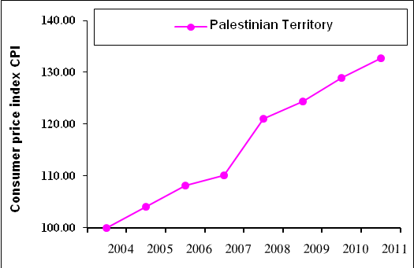

Note:
* Jerusalem J1: those parts of Jerusalem which were annexed by Israel in 1967
The data of West Bank doesn't cover Jerusalem J1.

