Palestinian Central Bureau of Statistics (PCBS)

Palestinian Consumer Price Index, October, 10/2013

Increase in the CPI during October 2013 compared with previous month
The overall Consumer Price Index (CPI) for Palestine during October 2013 increased by 0.82% compared with September 2013 (increased by 1.58% in the West Bank, and by 0.91% in Gaza Strip, and by 0.36% in Jerusalem J1*).

The CPI during October 2013 increased by 1.86% compared with October 2012 (3.63% in the West Bank, and by 1.70% in Jerusalem J1*, while it decreased by 0.17% in Gaza Strip).

The CPI during the first Ten months of 2013 increased by 1.66% compared with the same period of the previous year (3.01% in the West Bank, 1.77% in Jerusalem J1*, while it decreased by 0.68% in Gaza Strip).

The change in Consumer Price Index (CPI) for October 2013 is traced back to changes in prices of the following expenditure sub groups compared to the previous month:

Sub Groups | %Change
Fresh Vegetables | + 21.69%
Dried Vegetables | + 11.22%
Fresh Fruit | + 2.68%
Eggs | + 2.05%
Potatoes and other Tubers | + 1.44%
Vegetable Oils | + 1.18%
Gas | + 0.73%
Fresh Poultry | - 4.73%
Liquid Fuel for Cars | - 3.64%
Liquid Fuel for House | - 3.52%

The trend line for the consumer price index in Palestine for 2004 – 2012

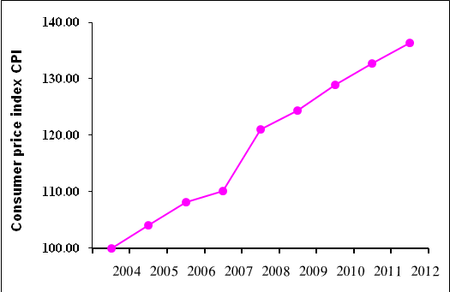

Note:
* Jerusalem J1: those parts of Jerusalem which were annexed by Israel in 1967
The data of West Bank doesn't cover Jerusalem J1.

