Palestinian Central Bureau of Statistics (PCBS)

Palestinian Consumer Price Index , October 2012

Decrease in the CPI of October 2012 compared with previous month
The overall Consumer Price Index (CPI) for the Palestinian Territory during October 2012 decreased by 0.60% compared with September 2012 (0.84% in the West Bank, 0.47% in Jerusalem J1*, 0.90% in Gaza Strip).

The CPI during October 2012 increased by 3.24% compared with October 2011 (5.53% in the West Bank, 3.81% in Jerusalem J1*, 0.30% in Gaza Strip).

The CPI during first Ten months of 2012 increased by 2.95% compared with the same period of the previous year (4.27% in the West Bank, 3.21% in Jerusalem J1*, 0.56% in Gaza Strip)
The change in Consumer Price Index (CPI) for October 2012 is traced back to changes in prices of the following expenditure sub groups compared to the previous month:

Sub Groups | %Change
Fresh vegetables | - 11.35%
Fresh fruit | - 2.16%
Sugar | - 3.23%
Gas | - 6.26%
Kerosene | - 9.85%
Fuel for transportation | - 1.15%

The trend line for the consumer price index in Palestinian Territory for 2004 – 2011
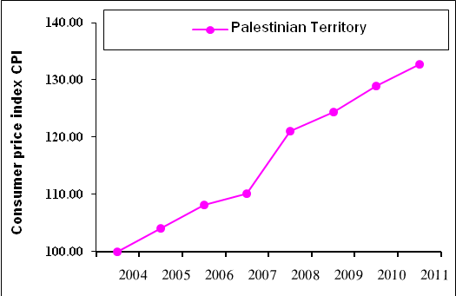

Note:
* Jerusalem J1: those parts of Jerusalem which were annexed by Israel in 1967
The data of West Bank doesn't cover Jerusalem J1.

