Palestinian Central Bureau of Statistics (PCBS)

Palestinian Consumer Price Index, September,09/2012

Increase in the CPI of September 2012 compared with previous month
The overall Consumer Price Index (CPI) for the Palestinian Territory during September 2012 increased by 1.42% compared with August 2012 (2.20% in the West Bank, 1.47% in Jerusalem J1*, 1.30% in Gaza Strip).

The CPI during September 2012 increased by 4.06% compared with September 2011 (6.48% in the West Bank, 4.54% in Jerusalem J1*, 1.25% in Gaza Strip).

The CPI during first nine months of 2012 increased by 2.92% compared with the same period of the previous year (4.13% in the West Bank, 3.14% in Jerusalem J1*, 0.59% in Gaza Strip)

The change in Consumer Price Index (CPI) for September 2012 is traced back to changes in prices of the following expenditure sub groups compared to the previous month:

Sub Groups | %Change
Fresh vegetables | + 15.49%
Eggs | + 13.36%
Sugar | + 8.25%
Fresh poultry | + 2.49%
Gas | + 4.41%
Fuel for transportation | + 2.52%

The trend line for the consumer price index in Palestinian Territory for 2004 – 2011

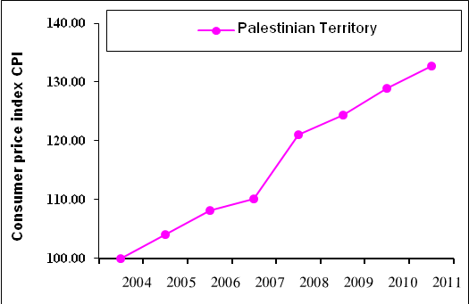

Note:
* Jerusalem J1: those parts of Jerusalem which were annexed by Israel in 1967
The data of West Bank doesn't cover Jerusalem J1.

