Palestinian Central Bureau of Statistics (PCBS)

Palestinian Consumer Price Index in the Palestinian Territory, August 2012

Remarkable Increase in the CPI of August 2012 compared with previous month
The overall Consumer Price Index (CPI) for the Palestinian Territory during August 2012 increased by 1.51% compared with July 2012 (2.23% in the West Bank, 1.58% in Jerusalem J1*, 0.35% in Gaza Strip).

The CPI during August 2012 increased by 3.33% compared with August 2011 (5.11% in the West Bank, 3.19% in Jerusalem J1*, 0.92% in Gaza Strip).

The CPI during first eight months of 2012 increased by 2.77% compared with the same period of the previous year (3.83% in the West Bank, 2.97% in Jerusalem J1*, 0.51% in Gaza Strip)

The change in Consumer Price Index (CPI) for August 2012 is traced back to changes in prices of the following expenditure sub groups compared to the previous month:

Sub Groups | %Change
Fresh vegetables | + 15.99%
Cigarettes | + 6.47%
Fuel for housing | + 4.80%
Fuel for transportation | + 4.51%

The trend line for the consumer price index in Palestinian Territory for 2004 – 2011

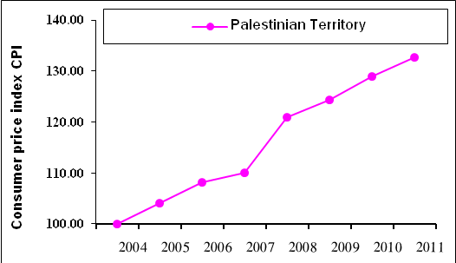

Note:
* Jerusalem J1: those parts of Jerusalem which were annexed by Israel in 1967
The data of West Bank doesn't cover Jerusalem J1.

