Palestinian Central Bureau of Statistics (PCBS)

Palestinian Consumer Price Index, June 2013

Increase in the CPI during June 2013 compared with previous month
The overall Consumer Price Index (CPI) for Palestine during June 2013 increased by 0.37% compared with May 2013 (increased by 0.92% in Jerusalem J1*, and by 0.25% in the West Bank, while it decreased by 0.25% in Gaza Strip).

The CPI during June 2013 increased by 2.70% compared with June 2012 (4.43% in the West Bank, and by 2.85% in Jerusalem J1*, while it decreased by 1.15% in Gaza Strip).

The CPI during the first six months of 2013 increased by 1.73% compared with the same period of the previous year (3.05% in the West Bank, 1.71% in Jerusalem J1*, while it decreased by 0.54% in Gaza Strip).

The change in Consumer Price Index (CPI) for June 2013 is traced back to changes in prices of the following expenditure sub groups compared to the previous month:

Sub Groups | %Change
Fuel for Housing | + 3.97%
Education | + 3.81%
Electricity | + 3.51%
Fuel for Transport | + 2.33%
Cigarettes & Cigar and Tobacco Products | + 1.78%
Medical Care | + 0.57%
Fresh Vegetables | - 4.67%
Potatoes and other Tubers | - 3.21%
Eggs | -1.21%

The trend line for the consumer price index in Palestine for 2004 – 2012

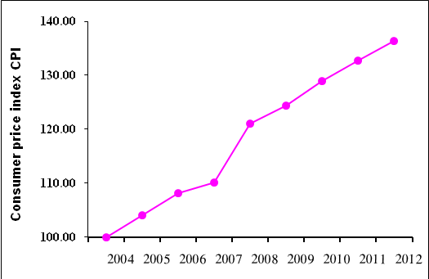

Note:
* Jerusalem J1: those parts of Jerusalem which were annexed by Israel in 1967
The data of West Bank doesn't cover Jerusalem J1.

