Palestinian Central Bureau of Statistics (PCBS)

Palestinian Consumer Price Index, May,05/2013

Increasing in the CPI during May 2013 compared with previous month
The overall Consumer Price Index (CPI) for Palestine during May 2013 increased by 0.10% compared with April 2013 (increased by 0.96% in the West Bank, and by 0.43% in Jerusalem J1*, while it decreased by 1.73% in Gaza Strip).

The CPI during May 2013 increased by 1.45% compared with May 2012 (3.03% in the West Bank, and by 1.27% in Jerusalem J1*, while it decreased by 1.86% in Gaza Strip).

The change in Consumer Price Index (CPI) for May 2013 is traced back to changes in prices of the following expenditure sub groups compared to the previous month:

Sub Groups | %Change
Cigarettes& Cigar and Tobacco products | + 6.98%
Fresh fruit | + 2.13%
Poultry | + 1.10%
Potatoes and other tubers | - 10.61%
Fuel for Housing | - 8.26%
Fuel for transportation | - 4.06%
Gas | - 3.80%

The trend line for the consumer price index in Palestine for 2004 – 2012

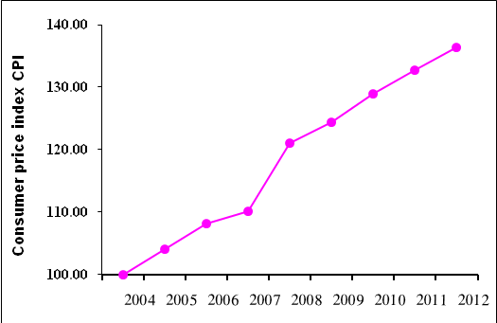

Note:
* Jerusalem J1: those parts of Jerusalem which were annexed by Israel in 1967
The data of West Bank doesn't cover Jerusalem J1.

