Palestinian Central Bureau of Statistics (PCBS)

Palestinian Consumer Price Index, April, 04/2013

Decreasing in the CPI during April 2013 compared with previous month

The overall Consumer Price Index (CPI) for Palestine during April 2013 decreased by 0.09% compared with March 2013 (decreased by 0.73% in Gaza Strip, and by 0.21% in Jerusalem J1*, while it increased by 0.13% in the West Bank).

The CPI during April 2013 increased by 1.14% compared with April 2012 (2.23% in the West Bank, 0.91% in Jerusalem J1*, while it decreased by 1.04% in Gaza Strip).

The change in Consumer Price Index (CPI) for April 2013 is traced back to changes in prices of the following expenditure sub groups compared to the previous month:

Sub Groups | %Change
Fuel for Housing | - 5.96%
Fuel for transportation | - 3.93%
Fresh vegetables | - 2.76%
Eggs | - 1.93%
Gas | - 1.03%
Potatoes and other tubers | + 11.16%
Fresh fruit | + 3.86%
Fresh meat | + 2.05%
Fresh poultry | + 1.94%

The trend line for the consumer price index in Palestine for 2004 – 2012

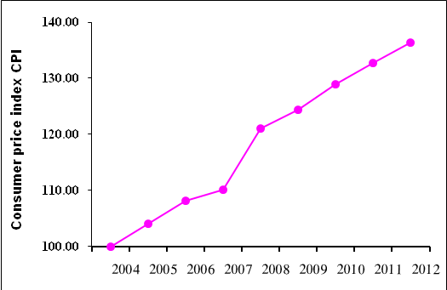

Note:
* Jerusalem J1: those parts of Jerusalem which were annexed by Israel in 1967
The data of West Bank doesn't cover Jerusalem J1.

