State of Palestine

Palestinian Central Bureau of Statistics (PCBS)

Palestinian Consumer Price Index, January 2013

Increasing in the CPI during January 2013 compared with previous month
The overall Consumer Price Index (CPI) for Palestine during January 2013 increased by 1.13% compared with December 2012 (increased by 1.15% in the West Bank, and by 0.56% in Gaza Strip, and by 0.43% in Jerusalem J1*).

The CPI during January 2013 increased by 2.36% compared with January 2012 (3.65% in the West Bank, 2.59% in Jerusalem J1*, 0.87% in Gaza Strip).

The change in Consumer Price Index (CPI) for January 2013 is traced back to changes in prices of the following expenditure sub groups compared to the previous month:

Sub Groups | %Change
Fresh vegetables | + 26.90%
Potatoes and other tubers | + 24.22%
Eggs | + 7.02%
Gas | + 2.95%
Fresh fruit | + 1.37%

The trend line for the consumer price index in the Palestine for 2004 – 2012

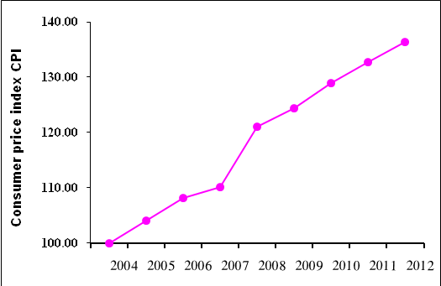

Note:
* Jerusalem J1: those parts of Jerusalem which were annexed by Israel in 1967
The data of West Bank doesn't cover Jerusalem J1.

