Palestinian Central Bureau of Statistics (PCBS)

Palestinian Consumer Price Index, August, 08/2013

Increase in the CPI during August 2013 compared with previous month
The overall Consumer Price Index (CPI) for Palestine during August 2013 increased by 0.37% compared with July 2013 (increased by 0.79% in Jerusalem J1*, and by 0.28% in the West Bank, and by 0.11% in Gaza Strip).
The CPI during August 2013 increased by 1.39% compared with August 2012 (2.56% in the West Bank, and by 2.07% in Jerusalem J1*, while it decreased by 0.84% in Gaza Strip).

The CPI during the first eight months of 2013 increased by 1.79% compared with the same period of the previous year (3.17% in the West Bank, 1.90% in Jerusalem J1*, while it decreased by 0.58% in Gaza Strip).
The change in Consumer Price Index (CPI) for August 2013 is traced back to changes in prices of the following expenditure sub groups compared to the previous month:

Sub Groups | %Change
Potatoes and other Tubers | + 14.63%
Fresh Vegetables | + 4.36%
Gas | + 3.13%
Dried Vegetables | + 2.83%
Fuel Oil for House | + 2.59%
Fuel for Cars | + 1.89%
Sugar | - 1.15%
The trend line for the consumer price index in Palestine for 2004 – 2012
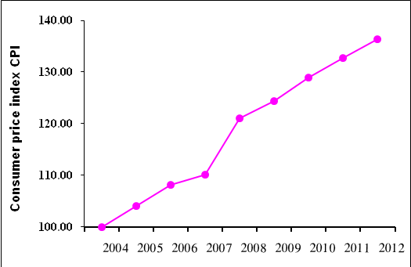

Note:
* Jerusalem J1: those parts of Jerusalem which were annexed by Israel in 1967
The data of West Bank doesn't cover Jerusalem J1.

