Palestinian Central Bureau of Statistics (PCBS)

Palestinian Consumer Price Index, March, 03/2013

Decreasing in the CPI during March 2013 compared with previous month
The overall Consumer Price Index (CPI) for Palestine during March 2013 decreased by 0.50% compared with February 2013 (decreased by 0.68% in Jerusalem J1*, and by 0.29% in Gaza Strip, and by 0.28% in the West Bank).

The CPI during March 2013 increased by 1.00% compared with March 2012 (2.21% in the West Bank, 0.86% in Jerusalem J1*, while it decrease by 0.33% in Gaza Strip).

The change in Consumer Price Index (CPI) for March 2013 is traced back to changes in prices of the following expenditure sub groups compared to the previous month:

Sub Groups | %Change
Fresh vegetables | - 10.45%
Eggs | - 9.88%
Potatoes and other tubers | - 9.49%
Sugar | - 3.30%
Education | + 4.57%
Fresh poultry | + 1.97%
Fresh fruit | + 1.29%

The trend line for the consumer price index in Palestine for 2004 – 2012

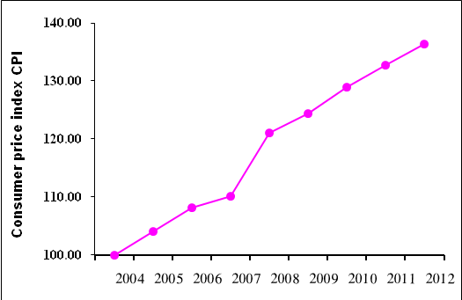

Note:
* Jerusalem J1: those parts of Jerusalem which were annexed by Israel in 1967
The data of West Bank doesn't cover Jerusalem J1.

