(PCBS) Building Licenses in Palestine, Fourth Quarter 2013

Number of building licenses in Palestine* decreased in the Fourth quarter 2013 compared to the previous quarter of 2013 and increased compared to the Fourth quarter of 2012

A total of 2,137 building licenses were issued in the Fourth quarter of 2013.

The total number of building licenses issued in the Fourth quarter of 2013 decreased by 3.7% compared to the Third quarter 2013. while, the total number of building licenses issued for the Fourth quarter of 2013 increased by 1.8% compared to the Fourth quarter of 2012.

The area of licensed buildings (residential and non-residential) totaled 855 thousand m², of which new buildings made up 683 thousand m² and existing buildings 172 thousand m².

The total number of licensed dwellings was 3,801 of which 2,927 were new units with a total area of 508 thousand m² and 874 were existing dwellings with a total area of 152 thousand m².

The number of new dwellings in the Fourth quarter of 2013 was decreased by 25.4% compared with the Third quarter of 2013 while it decreased by 20.3% compared with the Fourth quarter of 2012.

Number of Building Licenses issued in Palestine*, Fourth Quarter 2012 to Fourth Quarter 2013

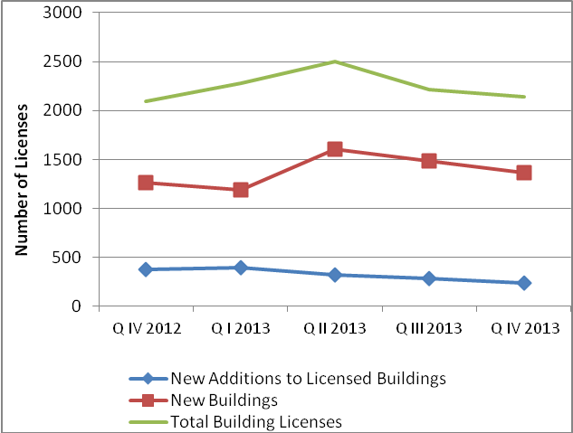

* The data exclude those parts of Jerusalem annexed by Israel in 1967.

