Palestinian Central Bureau of Statistics (PCBS)

Press Release on Building Licenses in Palestine, Second Quarter 2013

Number of building licenses in Palestine* rose compared to previous quarter of 2013 and the second quarter of 2012

A total of 2,501 building licenses were issued in the second quarter of 2013.

The total number of building licenses issued in the second quarter of 2013 increased by 9.6% compared to the first quarter 2013. Also, the total number of building licenses issued for the second quarter of 2013 was 14.2% higher than in the second quarter of 2012.

The area of licensed buildings (residential and non-residential) totaled 1.082 million m², of which new buildings made up 906 thousand m² and existing buildings 176 thousand m².

The total number of licensed dwellings was 4,369 of which 3,540 were new units with a total area of 593 thousand m² and 829 were existing dwellings with a total area of 145 thousand m².

The number of new dwellings in the second quarter of 2013 was 11.6% higher than in the first quarter of 2013 and 17.8% higher than the second quarter of 2012.

Number of Building Licenses issued in Palestine*, Second Quarter 2012 to Second Quarter 2013

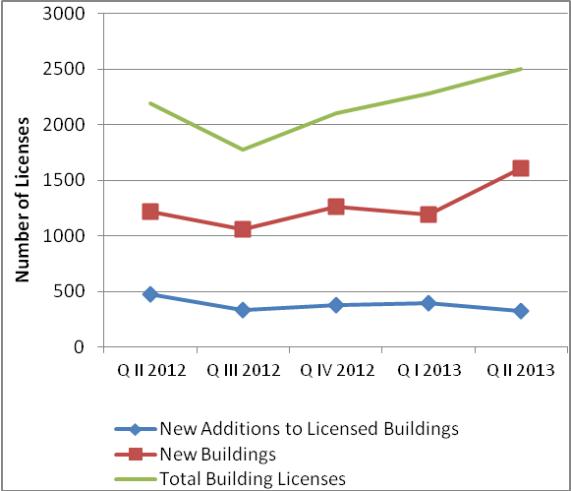

* The data exclude those parts of Jerusalem annexed by Israel in 1967.

