(PCBS) Building Licenses in Palestine, Fourth Quarter 2014

Number of building licenses in Palestine* increased in the Fourth quarter 2014 compared to the previous quarter of 2014 and increased compared to the Fourth quarter of 2013

A total of 2,144 building licenses were issued in the fourth quarter of 2014.

The total number of building licenses issued in the fourth quarter of 2014 increased by 5.1% compared with the third quarter of 2014, and was 0.3% higher than in the fourth quarter of 2013.

The area of licensed buildings (residential and non-residential) totaled 978 thousand m² in the fourth quarter of 2014, of which new buildings made up 855.6 thousand m² and existing buildings comprised 122.4 thousand m².

The total number of licensed dwellings in the fourth quarter 2014 was 4,116, of which 3,452 were new units with a total area of 618.7 thousand m² and 664 were existing dwellings with a total area of 104 thousand m².

The number of new dwellings in the fourth quarter of 2014 was 17.9% higher than the third quarter of 2014, and increased by the same percentage compared to the fourth quarter of 2013

Number of Building Licenses issued in Palestine* Fourth Quarter 2013 to Fourth Quarter 2014

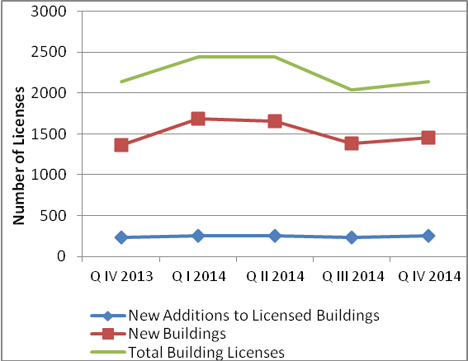

*The data excludes those parts of Jerusalem which were annexed by Israel in1967

