Palestinian Central Bureau of Statistics (PCBS)

Press Release on Building Licenses in Palestine, Third Quarter 2014

Decrease in the number of building licenses in Palestine*

A total of 2,039 building licenses were issued in the third quarter of 2014.

The total number of building licenses issued in the third quarter of 2014 decreased by 16.7% compared with the second quarter of 2014 and was 8.1% lower than in the third quarter of 2013.

The area of licensed buildings (residential and non-residential) totaled 917.6 thousand m² in the third quarter of 2014, of which new buildings made up 784.6 thousand m² and existing buildings comprised 133 thousand m².

The total number of licensed dwellings in the third quarter was 3,571, of which 2,929 were new units with a total area of 600.2 thousand m² and 642 were existing dwellings with a total area of 105.3 thousand m².

The number of new dwellings in the third quarter of 2014 was 18.5% lower than the second quarter of 2014 and 25.4% lower than the third quarter of 2013.

Number of Building Licenses issued in Palestine*,
Third Quarter 2013 to Third Quarter 2014

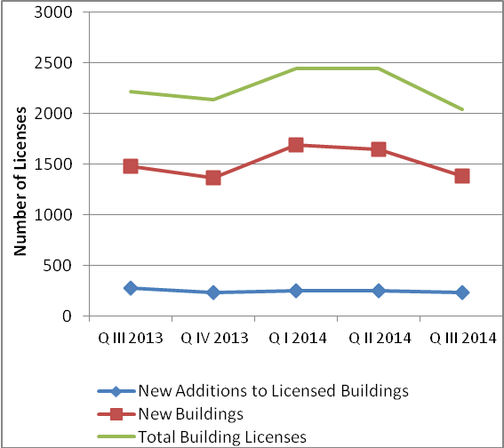

* The data excludes those parts of Jerusalem which were annexed by Israel in1967.

