Palestinian Central Bureau of Statistics (PCBS)

Press Release on Building Licenses in Palestine, Second Quarter 2015

Number of building licenses in Palestine* increased in the second quarter 2015 compared to the previous quarter of the same year and decreased compared to the corresponding quarter of 2014

A total of 2,345 building licenses were issued in the second quarter of 2015.

The total number of building licenses issued in the second quarter of 2015 increased by 19.0% compared with the first quarter of the same year while, decreased by 4.2% compared with the second quarter of 2014.

The area of licensed buildings (residential and non-residential) totaled 1,021.8 thousand m² in the second quarter of 2015, of which new buildings made up 891.4 thousand m² and existing buildings comprised 130.4 thousand m².

The number of licensed new dwellings in the second quarter of 2015 was 3,838 with a total area of 691.9 thousand m² and 665 were existing dwellings with a total area of 108.5 thousand m².

The number of new dwellings in the second quarter of 2015 was 19.0% higher than the first quarter of the same year, also increased by the 6.8% compared to the second quarter of 2014.

Number of Building Licenses issued in Palestine*, Second Quarter 2014 to Second
Quarter 2015

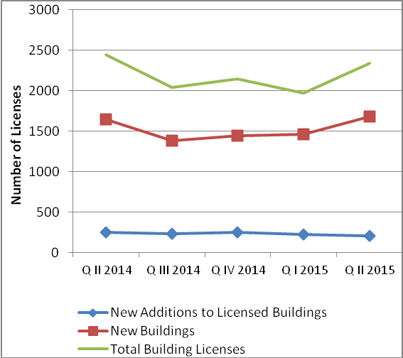

* The data excludes those parts of Jerusalem which were annexed by Israel in1967.

