Palestinian Central Bureau of Statistics (PCBS)

Press Release on Building Licenses in Palestine, First Quarter 2015

Decreased in the number of building licenses in Palestine*

A total of 1,970 building licenses were issued in the first quarter of 2015.

The total number of building licenses issued in the first quarter of 2015 decreased by 8.1% compared with the fourth quarter of 2014, and decreased by 19.4% compare with the first quarter of 2014.

The area of licensed buildings (residential and non-residential) totaled 895.7 thousand m² in the first quarter of 2015, of which new buildings made up 813.2 thousand m² and existing buildings comprised 82.5 thousand m².

The total number of licensed dwellings in the first quarter 2015 was 3,678, of which 3,226 were new dwellings with a total area of 595.3 thousand m² and 452 were existing dwellings with a total area of 75.3 thousand m².

The number of new dwellings in the first quarter of 2015 was 6.5% lower than the fourth quarter of 2014, and decreased by the 15.2% compared to the first quarter of 2014.

Number of Building Licenses issued in Palestine*,First Quarter 2014 to First
Quarter 2015

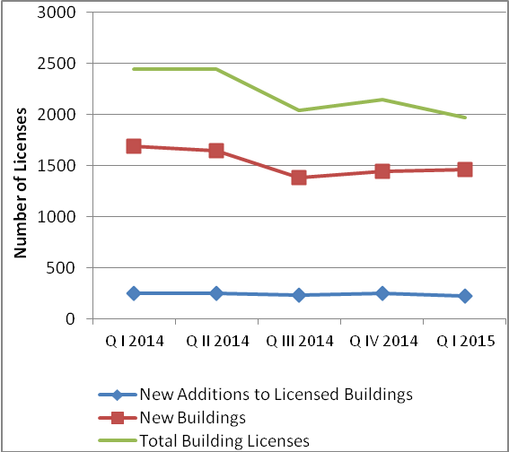

* The data excludes those parts of Jerusalem which were annexed by Israel in1967

