Palestinian Central Bureau of Statistics (PCBS)

Building Licenses in Palestine third quarter 2013

Decrease in the building licenses during third quarter 2013*

A total of 2,219 building licenses were issued in the Third quarter of 2013.

The total number of building licenses issued in the Third quarter of 2013 decreased by 11.3% compared to the second quarter 2013. while, the total number of building licenses issued for the Third quarter of 2013 increased by 24.8% compared to the Third quarter of 2012.

The area of licensed buildings (residential and non-residential) totaled one million m², of which new buildings made up 919 thousand m² and existing buildings 128 thousand m².

The total number of licensed dwellings was 4,582 of which 3,926 were new units with a total area of 675 thousand m² and 656 were existing dwellings with a total area of 106 thousand m².

The number of new dwellings in the Third quarter of 2013 was 10.9% higher than in the Second quarter of 2013 and 26.4% higher than in the Third quarter of 2012.

Number of Building Licenses issued in Palestine*, Third Quarter 2012 to Third Quarter 2013

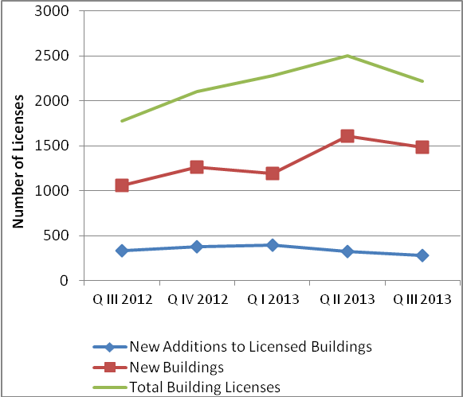

* The data exclude those parts of Jerusalem annexed by Israel in 1967.

