Palestinian Central Bureau of Statistics (PCBS)

Increase in the number of building licenses in Palestine* in the fourth quarter of 2020, due to the increase in the number of new building licenses

A total of 2,732 building licenses were issued in the fourth quarter of 2020 which included 1,798 for new buildings.

The total number of building licenses issued in the fourth quarter of 2020 increased by 38% compared with the third quarter of 2020 and increased by 3% compared with the fourth quarter of 2019, where the number of new building licenses increased by 33% compared with the third quarter of 2020 and decreased by 10% compared with the fourth quarter of 2019.

The area of licensed buildings (residential and non-residential) totaled 1,195 thousand m², of which new buildings made up 971 thousand m² and existing buildings comprised 224 thousand m².

The total number of licensed dwellings was 5,482 with a total area of 887 thousand m², of which 4,316 were new dwellings with a total area of 703 thousand m² and 1,166 were existing dwellings with a total area of 184 thousand m².

The number of new dwellings in the fourth quarter of 2020 increased by 52% compared with the third quarter of 2020 and decreased by 8% compared with the fourth quarter of 2019.

Number of Building Licenses Issued in Palestine* during the period, Fourth Quarter 2019 - Fourth Quarter 2020
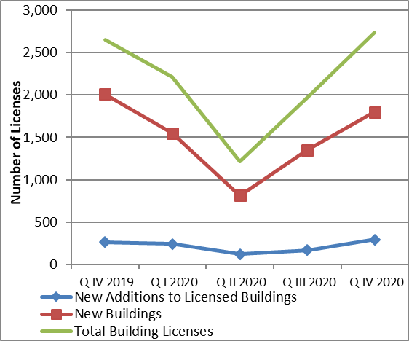

*Data excluded those parts of Jerusalem which were annexed by Israeli occupation in 1967.

