Palestinian Central Bureau of Statistics (PCBS)

Increase in the number of new building licenses in Palestine* by 7% during the third quarter of 2019 compared with previous quarter.

A total of 2,205 building licenses were issued in the third quarter of 2019 which included 1,451 for new buildings with an increase of 7% compared with the previous quarter.

The total number of building licenses issued in the third quarter of 2019 decreased by 2% compared with the second quarter of 2019 and decreased by 13% compared with the third quarter of 2018.

The area of licensed buildings (residential and non-residential) totaled 914 thousand m², of which new buildings made up 714 thousand m² and existing buildings comprised 200 thousand m².

The total number of licensed dwellings was 4,236 with a total area of 689 thousand m², of which 3,230 were new dwellings with a total area of 523 thousand m² and 1,006 were existing dwellings with a total area of 166 thousand m².

The number of new dwellings in the third quarter of 2019 increased by 5% compared with the second quarter of 2019 and decreased by 19% compared with the third quarter of 2018.

Number of Building Licenses Issued in Palestine* during the period,
Third Quarter 2018 - Third Quarter 2019

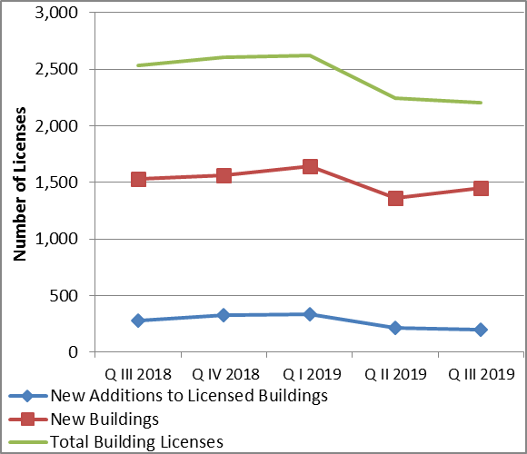

*Data excluded those parts of Jerusalem which were annexed by Israeli occupation in 1967.

