Palestinian Central Bureau of Statistics (PCBS)

Press Release by Palestinian Central Bureau of Statistics (PCBS) on the occasion of International Literacy Day, 08/09/2019

On the occasion of the International Literacy Day, 8th September 2019, Palestinian Central Bureau of Statistics announced that there were about 83 thousands illiterate persons among persons aged 15 years and above in 2018. According to the United Nations for Educational, Scientific and Cultural Organization (UNESCO) – the illiterate person applies to persons unable to read and write with understanding a simple statement related to one’s daily life. International Literacy Day 2019 will focus on ‘Literacy and Multilingualism.’ Despite progress made, literacy challenges persist, distributed unevenly across countries and populations. The UN's Sustainable Development Goals, adopted by world leaders in September 2015, promotes, as part of its agenda, universal access to quality education and learning opportunities throughout people’s lives. Sustainable Development Goal 4 has as one of its targets ensuring all young people achieve literacy and numeracy and that adults who lack these skills are given the opportunity to acquire them.

The illiteracy rate in Palestine is one of the lowest in the world
According to UNESCO Institute for Statistics, the illiteracy rate among persons 15 years and above in Arab States was 24.8% (about 64.6 million illiterate persons) in 2016: for males, 17.4% (23.7 million illiterate persons) compared to 32.8% for females (40.9 million illiterate persons). For the same year, the rate was 13.8% (about 750.1 million illiterate persons) in the world among the same age group: for males. 10.2% (277.2 million illiterate persons) compared to 17.3% for females (472.9 million illiterate persons).

The illiteracy rates reduced by 80% through the last two decades
Illiteracy rates among Palestinian population aged 15 years and above in Palestine fell in the period 1997-2018 from 13.9% to 2.8%. For males, the rate fell from 7.8% in 1997 to 1.3% in 2018, while for females it fell from 20.3% to 4.3% over the same period.
According to region, the rate fell from 14.1% in 1997 to 3.0% in 2018 in the West Bank while the rate fell in Gaza Strip from 13.7% in 1997 to 2.4% over the same period.

Illiteracy rates for persons (15 years and above) in Palestine
by sex for years 1997, 2000-2018

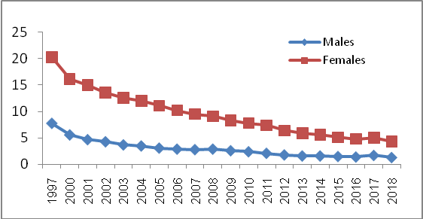

The illiteracy rate among females is higher than of males
In 2018, the illiteracy rate among persons 15 years and above in Palestine was 2.8% (82.8 thousand illiterate persons): 1.3% for males (20.2 thousand illiterate persons) and 4.3% for females (62.6 thousand illiterate persons). According to region, the illiteracy rate among persons 15 years and above in the West Bank was 3.0% (56.0 thousand illiterate persons): 1.3% for males (12.6 thousand illiterate persons) and 4.8% for females (43.4 thousand illiterate persons) in the same year. While the illiteracy rate among persons 15 years and above in Gaza Strip was 2.4% (26.8 thousand illiterate persons): 1.3% for males (7.6 thousand illiterate persons) and 3.4% for females (19.2 thousand illiterate persons).

More than half of illiterate persons are elderly
In 2018, the illiteracy rate among older persons aged 65 years and above reached about 29.7% (47.0 thousand illiterate persons). The rate was about 3.3% in the (45-64) year age group (19.0 thousand illiterate persons), 0.8% in the (30-44) year age group (7.0 thousand illiterate persons) and 0.7% among youth aged between (15-29) years (9.8 thousand illiterate persons) in the same year. The illiteracy rate varies considerably between age groups, where the age group 65 years and above got the highest rate, while the lowest rate was among the age groups (30-44) years and (15-29) years.

Percentage distribution and number of illiterate persons (15 years and above)
by age group, 2018

Age Group | Percentage (%) | Number (in thousands)
15-29 | 11.9 | 9.8
30-44 | 8.4 | 7.0
45-64 | 22.9 | 19.0
65 and above | 56.8 | 47.0
Total | 100.0 | 82.8

The illiteracy rate is the highest in rural areas compared to other localities
In 2018, the illiteracy rate among rural localities reached 3.7% (18.0 thousand illiterate persons), while scored 2.8% in the refugee camps (7.1 thousand illiterate persons) and 2.6% (57.7 thousand illiterate persons) in urban areas. In 2018, the female illiteracy rate was the highest in rural localities, followed by refugee camps and urban areas respectively. Male illiteracy rate did not vary by type of locality.

Illiteracy rate for persons (15 years and above)
by locality type and sex, 2018

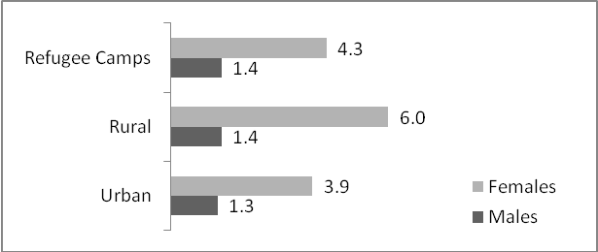

The highest illiteracy rate was in Salfit Governorate
In 2018, the highest illiteracy rate among persons aged 15 years and above was in Salfit governorate with 5.4%, followed by Jericho and Al Aghwar governorate with 3.9%. The lowest rate was in Gaza governorate with 2.0%. According to sex, the highest illiteracy rate among males aged 15 years and above was in Jerusalem governorate with 2.9% while the highest illiteracy rate among females for the same age group was in Salfit governorate with 9.2%.

Illiteracy rate and number of illiterate persons (15 years and above) by governorate and sex, 2018

Governorate | Both sexes |  | Males |  | Females
Governorate | Rate | Number  (in thousands) | Rate | Number  (in thousands) | Rate | Number  (in thousands)
Salfit | 5.4 | 2.6 | 1.7 | 0.4 | 9.2 | 2.2
Jericho & Al Aghwar | 3.9 | 1.3 | 1.9 | 0.3 | 6.0 | 1.0
Jerusalem | 3.5 | 7.4 | 2.9 | 2.9 | 4.1 | 4.5
Hebron | 3.4 | 15.4 | 1.6 | 3.9 | 5.3 | 11.5
Tubas & Northern Valley | 3.4 | 1.4 | 1.0 | 0.2 | 5.9 | 1.2
Rafah | 3.2 | 4.2 | 1.9 | 1.2 | 4.5 | 3.0
Qalqiliya | 3.2 | 2.3 | 1.1 | 0.4 | 5.5 | 1.9
Jenin | 3.0 | 6.5 | 1.2 | 1.4 | 4.9 | 5.1
Tulkarm | 2.8 | 3.5 | 0.8 | 0.5 | 4.8 | 3.0
Ramallah & Al-Bireh | 2.6 | 5.9 | 0.9 | 1.0 | 4.4 | 4.9
Khan Yunis | 2.5 | 5.4 | 1.7 | 1.9 | 3.3 | 3.5
North Gaza | 2.4 | 5.3 | 1.4 | 1.5 | 3.5 | 3.8
Dier al-Balah | 2.4 | 4.0 | 0.6 | 0.5 | 4.1 | 3.5
Bethlehem | 2.3 | 3.5 | 0.7 | 0.5 | 4.0 | 3.0
Nablus | 2.3 | 6.1 | 0.8 | 1.1 | 3.8 | 5.0
Gaza | 2.0 | 8.0 | 1.3 | 2.5 | 2.8 | 5.5
Total | 2.8 | 82.8 | 1.3 | 20.2 | 4.3 | 62.6

