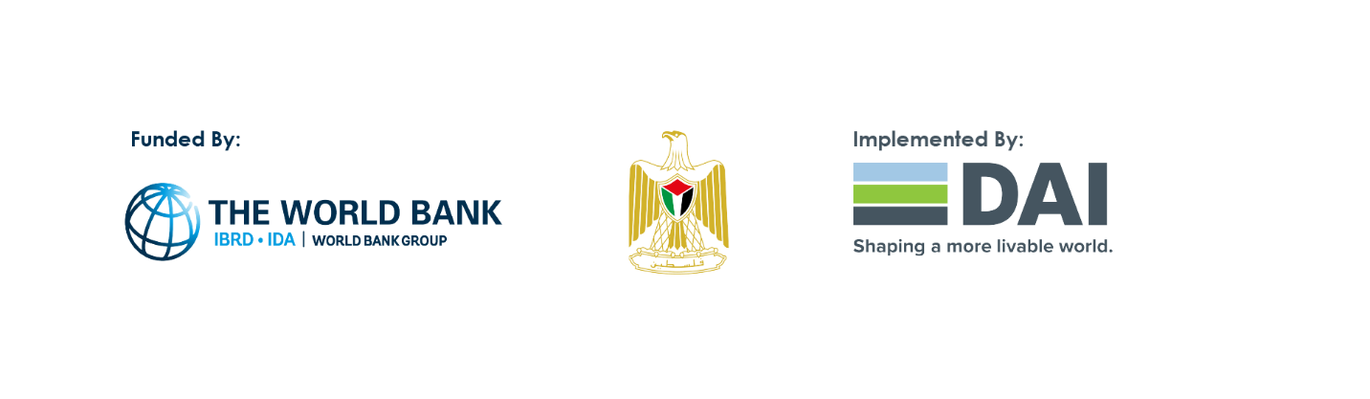
Palestinian Central Bureau of Statistics (PCBS) and Ministry of National Economy (MONE) and World Bank (WB) Issue a Statistical Report on the Impact of Coronavirus (COVID-19) Pandemic on Economic / Business Establishments During
(5/3/2021 – 31/5/2021)

Palestinian Central Bureau of Statistics (PCBS) in cooperation with Ministry of National Economy with a financial support by the World Bank conducted a survey; a second round, on the impact of COVID-19 on business establishments.

The results were released during a virtual workshop (via zoom) hosted by the Palestinian Central Bureau of Statistics (PCBS) and the Ministry of National Economy (MoNE) to discuss and analyze the results of the second round of the Impact of Coronavirus (COVID-19) Pandemic on Economic/Business Establishments Survey, 2021. It was implemented by the Palestinian Central Bureau of Statistics (PCBS) in cooperation with the Ministry of National Economy and was funded by the World Bank under the World Bank's program the Innovative Private Sector Development (IPSD).

A number of interested parties attended the workshop, which was led by partner representatives of the Ministry of National Economy, and the Palestinian Central Bureau of Statistics, in addition to some partners from international institutions, including the World Bank, GIZ, as well as representatives from ministries, NGOs, and the private sector.

Mr. Ahmed Al-Safadi, the Technical Advisor for the Project to Support Private Sector Innovations, inaugurated the workshop by briefing the attendees on the project, the source of funding, and the extent of joint cooperation during the implementation between the Palestinian Central Bureau of Statistics and the Ministry of National Economy.

Mr. Rashad Yousef, the Representative of the Ministry of National Economy, highlighted the economic sectors affected by the coronavirus (COVID-19) pandemic in general. Mr. Yousef also appreciated the cooperation with the Palestinian Central Bureau of Statistics in carrying out this project.

Ms. Haleema Saeed, Director General of the International Relations at the Palestinian Central Bureau of Statistics, spoke about the survey and commended the remarkable efforts of the work team throughout the project up to releasing the results. Ms. Saeed also expressed her gratitude and appreciation to the World Bank for funding the initiative for the second time in a row.

In the same context, Ms. Ashwaq Sadaqa, Project Manager, delivered a presentation on the results and conclusions of the survey, noting that the overall indicator suggested a slight increase in the Palestinian economy during the reference period (5/3-31/5 / 2021) compared to the same period in 2020. At the end of Ms. Sadaqa's presentation, all inquiries of the attendees were answered.

Mr. Ahmed Al-Safadi concluded the workshop by stressing on the importance of the survey in diagnosing the performance of economic establishments during the pandemic, and that the results will later be based on in-depth and analytical studies to provide the government with a basis for taking appropriate decisions to reduce the economic effects of the pandemic.

The results of sample (2600 establishments) indicated that the Coronavirus pandemic made business establishments suffer from demand and supply shocks and financial shocks, which, in return, made establishments turn to take financial and administrative measures as well as digital solutions to face the impacts of the pandemic.

The results of the survey are one of the MONE initiatives to empower the private sector in Palestine, through adopting different policies in this sector. Thus, the ministry took the initiative to evaluate the impact of COVID-19 pandemic on the private sector through a project for supporting the innovations of the private sector. This project is funded by the World Bank for the benefit of MONE, and is being conducted by Development Alternatives Incorporated (DAI) in cooperation with PCBS.

The importance of this survey lies in identifying the needs of business establishments that emerged due to the outbreak of COVID-19 pandemic. The survey also aims to help MONE, in cooperation with partners from different sectors, to design programs that are responsive to the needs of the effected business establishments to ensure their recovery and return to market or to continue their businesses, according to results and outcomes of the surveys.

The main results of a survey on the impact of COVID-19 on business establishments during lockdown period (5/3/2021– 31/5/2021):

An improvement in the average percentage change in the production/sales of establishments in 2021 compared with previous year through the period (5/3-31/5)
The percentage of establishments that witnessed a decline in production or sales through (5/3-31/5/2021) compared with the normal situation is lower in 2021 compared to 2020. This percentage was 93% in 2020, while it declined to 82% in 2021. This decrease has led to an improvement in the average percentage change in the production of establishments compared with the normal situation, where it declined from 51% in 2020 to 43% in 2021, which means that there is an improvement in the production of establishments during 2021.

Establishments operating in the construction and transport sectors recorded the highest percentage of establishments that witnessed a decrease in production by 51% compared with normal situation, followed by industry sector with a decline of 48%.

A decrease in the percentage of closure days in 2021 in Palestine compared with the same period (5/3– 31/5) of the year 2020:
Results show a decrease in the percentage of closure days. It was 51 % in 2020, whereas it declined to 27 % in 2021. Mainly in Telecommunications activities with a percentage reached to 42%, Transport 34%, while it reached for Industry and Trade activities 29% and 24% respectively.

49% of establishments reported having difficulties in the supply of inputs and raw materials in 2021 compared with 63% of establishments for year 2020 through the same period (5/3– 31/5):
Regarding supply shocks, an improvement in the supply of inputs, raw materials or finished goods and materials purchased, where 63% of surveyed establishments stated facing difficulties in 2020 compared to 49% in 2021.
Hence, economic activities suffering the most from these difficulties were trade activities with a percentage of 52%, industry at 50% and construction at 47%.

An improvement in the indicator of shortage cash flow for and decline in the percentage of returned checks in 2021 compared with previous year through the period (5/3-31/5)
An improvement in the indicator of cash flow shortage in establishments, where the percentage of establishments facing shortage in the cash flow was 89% in 2020 compared to 74% in 2021. Meanwhile, an improvement in the percentage of returned checks in 2021, to be 26% in 2021 compared to 36% in 2020. While, 35% of the establishments reported having a difficulty in the provision of financial services that are usually available in the normal situation.

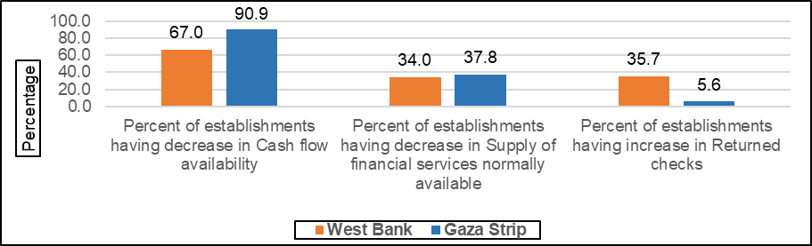

33% of the establishments in 2021 had to have delay payments to suppliers and employees to face shortage in cash flow compared with 37% in 2020.
33% of establishments in 2021 forced to delay payments to suppliers and employees, compared with 37% in 2020. Medium sized establishments reported the highest percentage of establishments being forced with a percentage 40%, followed by 33% for large establishments, and 28% for small establishments.

On the other hand, 47% of establishments had received loans from non-financial institutions such as friends, family, relative, other income, etc. to deal with the shortage of cash flow.

An improvement in an employment in 2021 compared with the same period of 2020
Results showed an improvement in an employment in 2021 compared with the same period of 2020. However, the decrease in the closure days led to an increase in the percentage of establishments that hired employees to 4% in 2021 compared with 2% in 2020. In addition, it led to a decrease in the percentage of fired employees from 14% in 2020 to 9% in 2021.

Whereas 4% of the establishments reduced the salaries and wages of their employees, and 3% of them gave their employees unpaid leave, while 2% of them gave their employees a paid leave, while 8% of the establishments responded to have suspended employees from work due to infection or contact with a person infected with Covid-19.

An increase in the percentage of establishments that use internet in 2021 compared with the same period (5/3– 31/5) of 2020
The results of the survey showed an increase in the percentage of establishments that use internet, social media networks, specialized apps, or digital platforms from 12% in 2020 to 18% in 2021.
Whereas the main use of such digital solutions was for marketing with a percentage of 83%, 53% for business administration and 38% for selling.
On the other hand, the percentage of employees who are currently working remotely was 8% of the total number of employees; mainly in the telecommunication sector (12% of the total number of employees) and transport sector (9% of the total number of employees). The main results also showed that the highest percentage of employees who were working remotely was among large establishments with a percentage of (18%).

Needed policies: (67% of establishments chose utility subsidies as the most needed policies to support their businesses)
67% of the establishments chose utility subsidies such as electricity, water, wastewater, internet services, and others, as the most needed policies to support their businesses over COVID-19 crisis. While 47% of the establishments chose exemptions or tax deductions, followed by salary subsidies with 41% and 40% for rental deferral.

