Palestinian Central Bureau of Statistics (PCBS)

Palestinian Central Bureau of Statistics (PCBS), issued a press release on the
Eve of the International Women’s Day on Thursday, 08/03/2018

Women represent half of the Palestinian population
The qualitative base of the structure of the population in Palestine the sex ratio stood at 103.3, which means that there are 103 males for every 100 females

The percentage of female-headed households
The percentage of female-headed households in Palestine was 10.6% in 2017, 11.2% in the West Bank and 9.5% in Gaza Strip.

fifth of the persons in Palestine got married at an early age (less than 18 years) in 2016
Early marriage reached to 20.5% among females and 1.0% among males of the total married population in Palestine; the rate was 19.9% out of the total married population in West Bank and 21.6% out of the total married population in Gaza Strip end 2016.

The highest rate of female early marriage in the West Bank was in Hebron 36.8%, and the lowest was in Jericho and the Jordan Valley 1.2% out of the total number of women marriage below 18 years in the West Bank. In Gaza Strip, the highest rate of early female marriage was 42.1% in Gaza Governorate, while the lowest rate was in Dier Al-Balah 7.1% out of the total number of women marriage below 18 years in Gaza Strip.

A continued rise in literacy among women
Despite the rise in literacy rates among females over the last decade, the gap is still in favor of males by 3.0%, female literacy rates was 95.6% compared to 98.6% for male literacy in the year 2017.

Literacy rates for men and women population aged 15 years and above, 2001-2017
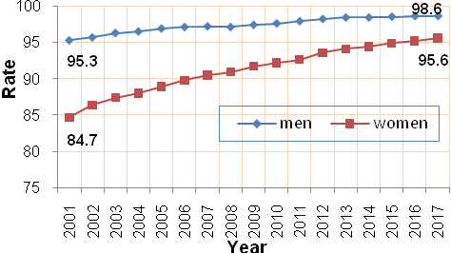

Rise in enrollment rate of females in high schools compared to males
Data showed that male enrollment in high schools was 60.5%, compared to female enrollment which was 80.4% for the year 2016-2017.

Gross enrollment rates in high schools by sex for the scholastic years (2009/2010 – 2016/2017)

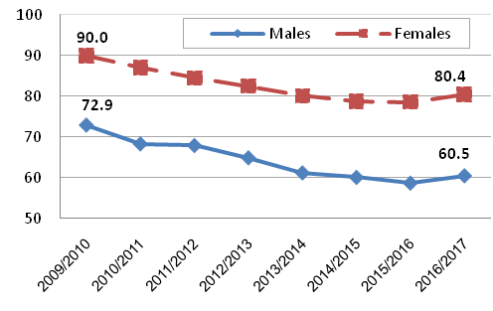

A gap in the participation rate and average daily wages between men and women
The female participation rate in the labor force was 19.0% of the total female population at work age in 2017, compared to 10.3% in 2001, while the male participation rate was 71.2% in 2017. There was also a pay gap in the average daily wages between males and females; the average daily wage for females was NIS 84.6 compared to NIS 119.6 for males.

Percentage of men and women participation in the labor force aged 15 years and above, 2001-2017
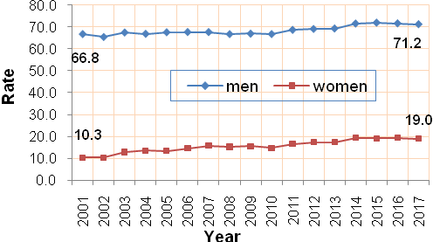
Around half of the women are unemployed
The unemployment rate among women participated in the labor force was 47.4% compared to 22.3% for participated males. 65.8% of youth females aged of (15-29 years) were unemployed. While the unemployment rate among women with 13 school years and above represents 53.8% of women in this group.

Unemployment rate among men and women 15 years and above 2001-2017
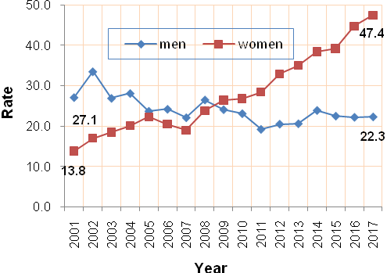

Palestinian Women in Public Life
In 2017; 21.2% of the members of the local councils are females in the West Bank while 78.8% were males.

In 2016, 82.7% of judges were male, compared to 17.3% female, while 66.6% of registered lawyers were male, compared to 33.4% female and 82.0% of members of the public prosecution staff were male, compared to 18.0% female. Furthermore, Palestinian female ambassadors represented 5.8% compared to 94.2% male. Females represented 32.3% of registered engineers with the Union of Engineers while male represented 67.7%. On the other hand, in 2016, 12.4% of members of student councils in West Bank universities were females, compared to 87.6% males.

In the public sector, females represented 42.7% of civil servants, compared to 57.3% male civil servant. In the public civil sector, female Director Generals represented 11.3% of the total director generals, compared to 88.7% males in the same post.

