H. E. the President receives the Main Results Report on the Palestinian Refugees in the Palestinian Refugee Camps and Localities Census in Lebanon

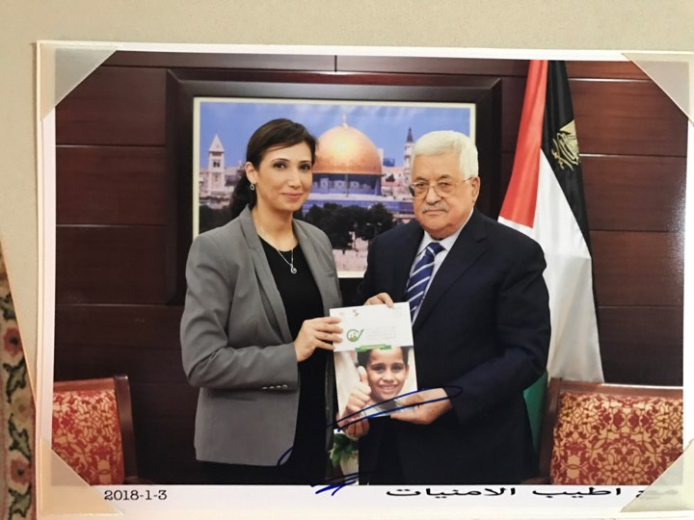

Ramallah, 03/01/2018 – H. E. President Mahmoud Abbas received the Main Results Report on the Palestinian Refugees in the Palestinian Refugee Camps and Localities Census in Lebanon during a meeting with Ms. Ola Awad, President of the Palestinian Central Bureau of Statistics (PCBS), where Ms. Awad briefed H. E. the President on the most important results in addition to the progress made on the Population, Housing and Establishments Census 2017 in all governorates of Palestine.

H. E. President Mahmoud Abbas commended Ms. Awad and the Palestinian Central Bureau of Statistics for their distinct efforts that all Palestinians are proud of.

