Palestinian Central Bureau of Statistics (PCBS)

Preliminary Estimates of Quarterly National Accounts

(Fourth Quarter 2017)

Main Results

Increase in GDP at constant prices in Palestine* during the 4th quarter 2017 compared to the parallel quarter (4th quarter 2016)
Preliminary estimates at constant prices showed an increase of 5.4% in GDP in Palestine* during the 4th quarter 2017 compared to the 4th quarter 2016, (increase 8.4% in the West Bank* and decrease 2.9% in Gaza Strip compared to the 4th quarter 2016). And it showed a decrease of 0.7% in Palestine* compared to the 3rd quarter 2017 at constant prices, meanwhile the base year is 2015. GDP for the 4th quarter 2017 at constant prices was USD 2,643.4 million for the West Bank* and USD 833.1 million for Gaza Strip. In addition, an increase of 3.1% was in GDP in Palestine* during the year 2017 compared to the year 2016 at constant prices.

Gross Domestic Product Per Capita
GDP per Capita for Palestine* at constant prices was USD 734.9 during the 4th quarter 2017, it showed an increase of 2.3% compared to the 4th quarter 2016. As for the West Bank* it was USD 956.6 at constant prices during the 4th quarter 2017, it showed an increase by 6% during the 4th quarter 2017 compared to the 4th quarter 2016, while for Gaza Strip it was USD 423.5 during the 4th quarter 2017, and it showed a decrease by 6.9% during the 4th quarter 2017 compared to the 4th quarter 2016.

Quarterly GDP in Palestine* at Constant Prices for the Years 2013-2017
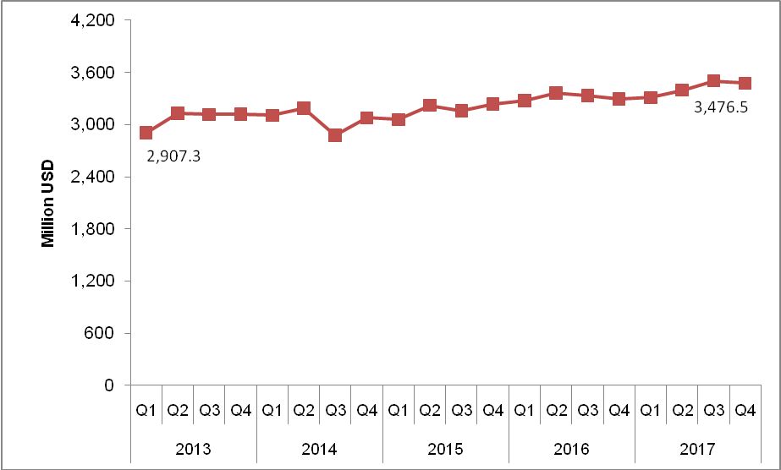

* The data excludes those parts of Jerusalem governorate which were annexed by Israel in 1967.
*

