Palestinian Central Bureau of Statistics (PCBS)

Main Results

Gross Domestic Product (GDP) at constant prices increased by 7% in Palestine during the 3rd quarter 2021 compared to the parallel quarter 2020

Primary estimates for GDP at constant prices showed an increase of 7% in GDP in Palestine during the 3rd quarter 2021 compared to the 3rd quarter 2020 which excludes the seasonal effect, meanwhile the base year is 2015. GDP for the 3rd quarter 2021 at constant prices was USD 3,111 million for the West Bank and USD 628 million for Gaza Strip.

On the other hand, it showed a slight increase of 0.1% in Palestine during the 3rd quarter 2021 compared to the 2nd quarter 2021 at constant prices, mainly in (Information and Communication, Mining, Manufacturing, Electricity and Water by 8%), Transportation and Storage 7%, Services 6%, Construction 4%, (Financial and Insurance Activities, Public Administration and Defense 3%), Wholesale and Retail Trade, Repair of Motor Vehicles and Motorcycles 1%.

Increase in Gross Domestic Product Per Capita
GDP per Capita for Palestine at constant prices was USD 756 during the 3rd quarter 2021, it showed an increase of 4% compared to the parallel quarter 2020. As for the West Bank it was USD 1,097 at constant prices during the 3rd quarter 2021, it showed an increase by 4% during the 3rd quarter 2021 compared to the parallel quarter 2020, while for Gaza Strip it was USD 297 during the 3rd quarter 2021, and it showed an increase by 1% during the 3rd quarter 2021 compared to the parallel quarter 2020.

GDP by quarter in Palestine at Constant Prices, 2017-2021
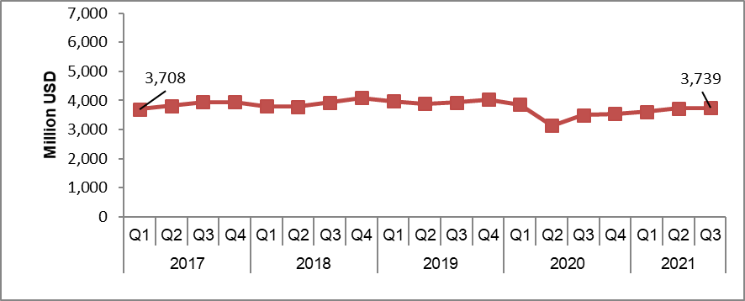

The data excluded those parts of Jerusalem which were annexed by Israeli Occupation in 1967

