Palestinian Central Bureau of Statistics (PCBS)

Preliminary Estimates of Quarterly National Accounts

(Third Quarter 2016)

Main Results

Increase in GDP at constant prices in Palestine* during the 3rd quarter 2016 compared to the parallel quarter (3rd quarter 2015)
Preliminary estimates at constant prices showed an increase of 5.2% in GDP in Palestine* during the 3rd quarter 2016 compared to the 3rd quarter 2015, (increase 3.9% in the West Bank* and increase 9.7% in Gaza Strip compared to the 3rd quarter 2015). And it showed a decrease of 0.4% in Palestine* compared to the 2nd quarter 2016 at constant prices, meanwhile the base year is 2004. GDP for the 3rd quarter 2016 at constant prices was USD 1,533.9 million for the West Bank* and USD 489.2 million for Gaza Strip.

Gross Domestic Product Per Capita
GDP per Capita for Palestine* at constant prices was USD 442.9 during the 3rd quarter 2016, it showed an increase of 2.3% compared to the 3rd quarter 2015. As for the West Bank* it was USD 572.6 at constant prices during the 3rd quarter 2016, it showed an increase by 1.3% during the 3rd quarter 2016 compared to the 3rd quarter 2015, while for Gaza Strip it was USD 259.0 during the 3rd quarter 2016, and it showed an increase by 6.1% during the 3rd quarter 2016 compared to the parallel quarter 2015.

Quarterly GDP in Palestine* at Constant Prices for the Years 2012-2016
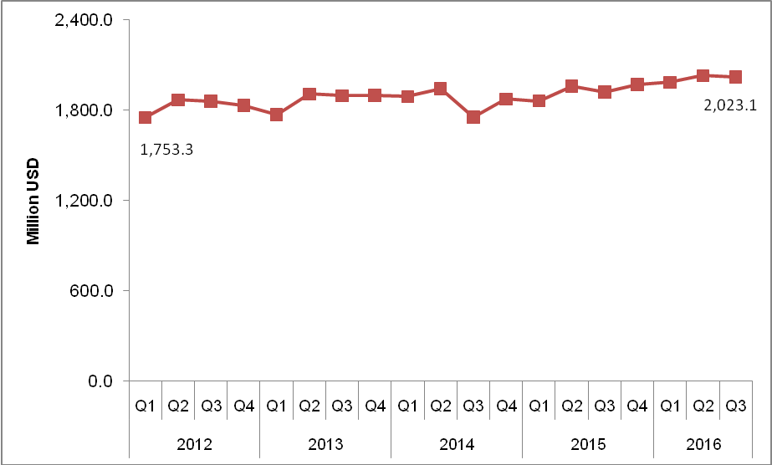

* The data excludes those parts of Jerusalem governorate which were annexed by Israel in 1967.

