Within its weekly session headed by H.E. the Prime Minister Dr. Rami Alhamdallah
The Ministers Council welcomes the launching of the third phase of the
Population, Housing and Establishments Census 2017 "The Actual Count of Population" in the State of Palestine
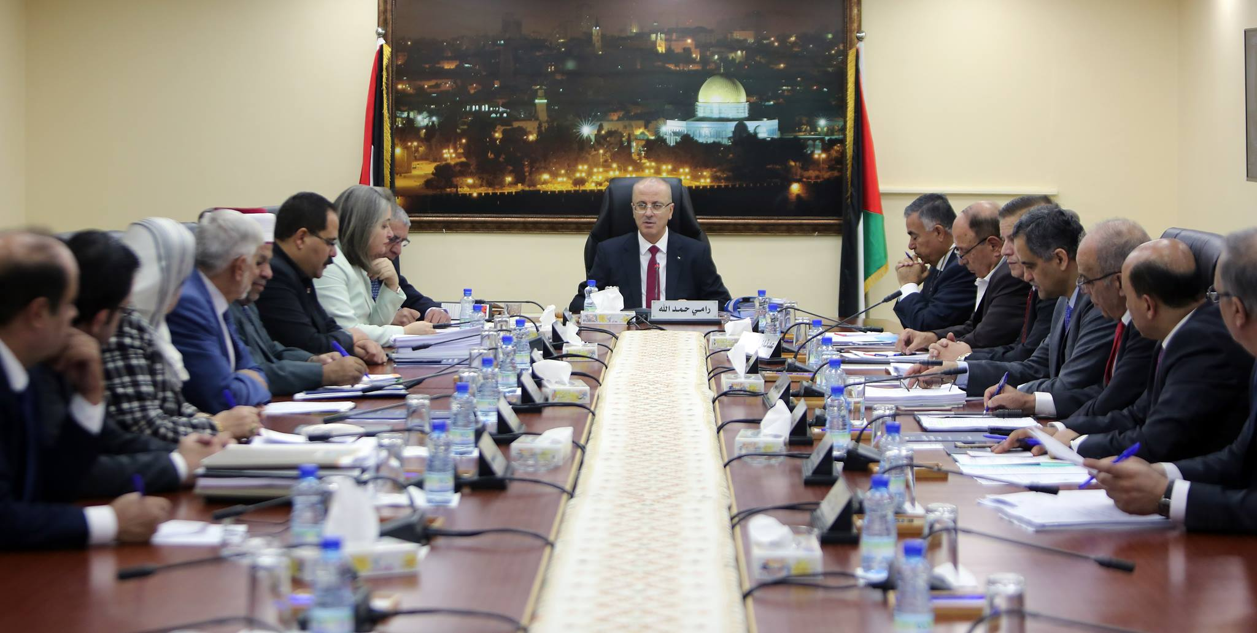

Ramallah – 28/11/2017- The Ministers Council welcomed the launching of the Palestinian Central Bureau of Statistics (PCBS) for the third phase of the Population, Housing and Establishments Census (PHC) 2017 in the State of Palestine, "The Actual Population Count" which will be launched from 01 - 24/12/2017, with the support and guidance of His Excellency President Mahmoud Abbas and the Prime Minister Dr. Rami Hamdallah with the cooperation and support of all public and private institutions and the media. This phase is represented through the actual count of the population in all the Palestinian governorates, after the success and completion of the implementation of the preparatory phase (Listing, enumeration and delineation phases). The enumeration team will visit all Palestinian families to collect statistical data on family members and their demographical, social and economical characteristics and their living conditions. The Cabinet called on all families to cooperate with the PHC 2017 team. The Cabined appreciates this process, which is carried out for the third time by Palestinian hands and by an independent Palestinian decision where in addition to the fact that it will be implemented for the first time by the using "Tablets". It is worth mentioning that the census is the largest statistical operation to be implemented in order to provide the necessary data for planning purposes of economic and social development where the census data will be used for development planning purposes.
The PHC 2017 includes all of those who are available and present in the State of Palestine on the night of 01/12/2017, regardless of the type of document they hold, this will include other nationalities in Palestine, whether they are here on a visit or as residents, the census will also include: family members who are abroad temporarily for a period of less than one year for work reasons and they visit their homeland periodically, it will also include people on business travel, tourists or people performing Umrah, people abroad seeking medical treatment, students studying abroad regardless of the period of absence.

The government called all citizens to cooperate with the PHC 2017 staff by providing accurate information about them, stressing that the statistical data collected from the field is purely collected for statistical purposes, and that the publication of its findings will be in form of statistical tables where PCBS is committed to maintain the confidentiality of individual data according to the General Statistics Law 2000.

