Palestinian Central Bureau of Statistics (PCBS)

A decrease in Exports on Registered* Goods in January, 012020/ by 23% compared to December, 12/2019

Exports in Goods
Exports decreased in January, 2020 by 23% compared to December, 2019. While it increased by 3% compared to January, 2019 and reached USD 84.8 Million.

Exports to Israel decreased in January, 2020 by 22% compared to December, 2019 and it represented 85% of total exports in January, 2020.

At the same time, exports to other countries decreased by 32% during the same period compared to December, 2019 and reached USD 12.9 Million.

Imports in Goods
Imports decreased in January, 2020 by 7% compared to December, 2019. It also decreased by 6% compared to January, 2019 and reached USD 473.9 Million.

Imports from Israel decreased by 7% in January, 2020 compared to December, 2019 and it represented 56% of total imports in January, 2020.

At the same time, imports from other countries decreased by 7% compared to December, 2019.

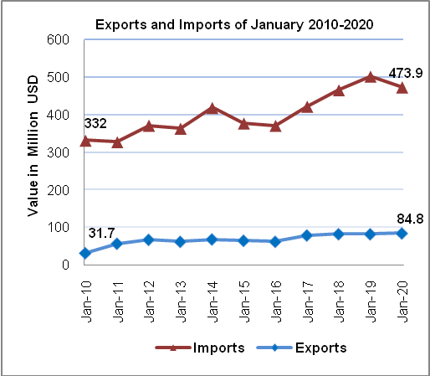

Trade Balance on Registered Goods
The trade balance which represents the difference between exports and imports showed a decrease in trade deficit by 3% in January, 2020 compared to December, 2019. It also decreased by 7% compared to January, 2019 and reached USD 389.1 Million.

(*): Includes actual data received from official sources.

