Palestinian Central Bureau of Statistics (PCBS)

A decrease in Exports and Imports on Registered* Goods in January, 2021 compared to the previous month. And an increase compared to the corresponding month of 2020.

A decrease in Exports in January, 2021
Exports decreased in January 2021 by 21% compared to December, 2020. While it increased by 20% compared to January, 2020 and reached USD 101.8 Million.

Exports to Israel decreased in January, 2021 by 17% compared to December, 2020 and it represented 87% of total exports in January, 2021.

At the same time, exports to other countries decreased by 38% during the same period compared to December, 2020 and reached USD 13.4 Million.

A decrease in Imports in January, 2021
Imports decreased in January, 2021 by 5% compared to December, 2020. While it increased by 4% compared to January, 2020 and reached USD 491.9 Million.

Imports from Israel increased by 3% in January, 2021 compared to December, 2020 and it represented 57% of total imports in January, 2021.

On the other hand, imports from other countries decreased by 13% compared to December, 2020.
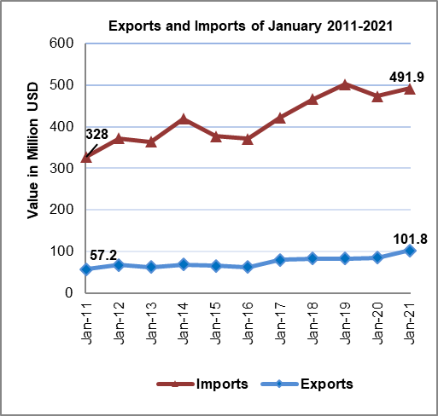
A slightly increase in Trade Balance
The trade balance which represents the difference between exports and imports showed an increase in trade deficit by 1% in January, 2021 compared to December, 2020. It also slightly increased by 0.3% compared to January, 2020 and reached USD 390.1 Million.

