Palestinian Central Bureau of Statistics (PCBS)

An increase in Exports on Registered* Goods in December, 12/2019 by 17% compared to November, 11/2019

Exports in Goods
Exports increased in December, 2019 by 17% compared to November, 2019. It also increased by 10% compared to December, 2018 and reached USD 110.6 Million.

Exports to Israel increased in December, 2019 by 22% compared to November, 2019 and it represented 83% of total exports in December, 2019.

On the other hand, exports to other countries decreased by 1% during the same period compared to November, 2019 and reached USD 18.9 Million.

Imports in Goods
Imports increased in December, 2019 by 8% compared to November, 2019. It also increased by 3% compared to December, 2018 and reached USD 509.9 Million.

Imports from Israel increased by 10% in December, 2019 compared to November, 2019 and it represented 56% of total imports in December, 2019.

At the same time, imports from other countries increased by 6% compared to November, 2019.

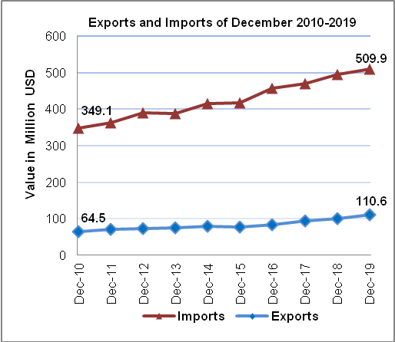
Trade Balance on Registered Goods
The trade balance which represents the difference between exports and imports showed an increase in trade deficit by 6% in December, 2019 compared to November, 2019. It also increased by 1% compared to December, 2018 and reached USD 399.3 Million.

(*): Includes actual data received from official sources

