Palestinian Central Bureau of Statistics (PCBS)

An increase in Exports on Registered* Goods in November, 2019 by 6% compared to October, 2019

Exports in Goods
Exports increased in November, 2019 by 6% compared to October, 2019. While it decreased by 1% compared to November, 2018 and reached USD 94.3 Million.

Exports to Israel increased in November, 2019 by 3% compared to October, 2019 and it represented 80% of total exports in November, 2019.

At the same time, exports to other countries increased by 19% during the same period compared to October, 2019 and reached USD 19 Million.

Imports in Goods
Imports slightly increased in November, 2019 by 0.1% compared to October, 2019. While it decreased by 4% compared to November, 2018 and reached USD 472.4 Million.

Imports from Israel decreased by 4% in November, 2019 compared to October, 2019 and it represented 55% of total imports in November, 2019.

On the other hand, imports from other countries increased by 6% compared to October, 2019.

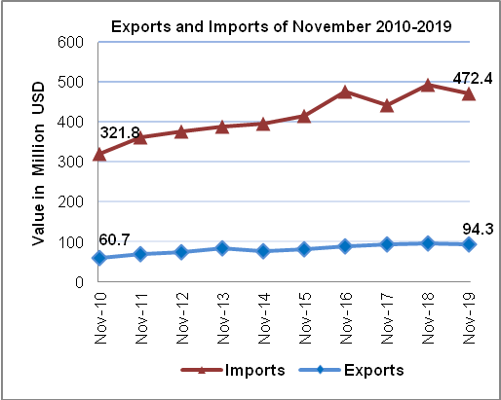

Trade Balance on Registered Goods
The trade balance which represents the difference between exports and imports showed a decrease in trade deficit by 1% in November, 2019 compared to October, 2019. It also decreased by 5% compared to November, 2018 and reached USD 378.1 Million.

