The Palestinian Central Bureau of Statistics (PCBS) and the Palestinian Water Authority (PWA) Issue a Press Release on the Occasion of World Water Day, March 22, 2017

Theme for World Water Day 2017 is "Water and Waste Water"

On the occasion of World Water Day, March 22, PCBS and PWA Issue a Press Release. The UN announced that the theme of World Water Day 2017, is "water and wastewater".

104 localities had wastewater networks and 508 localities were connected to public water networks

Data showed that 104 localities in Palestine in 2015 were connected to wastewater networks out of 557 localities.

508 localities in Palestine were connected to public water networks, compared with 458 localities in 2013.

95% of the Palestinian Households had access to an improved water source

The results of 2015 showed that 94.9% of households in Palestine live in housing units with access to an improved water source according to Sustainable Development Goals (SDGs) definition, which includes public network and domestic well.

54% of households were connected to wastewater networks

During 2015, data indicated that 53.9% of households in Palestine were connected to wastewater networks to dispose of their wastewater, while 31.8% of households used porous cesspits.

Percentage of Households by Wastewater Disposal Method and Region, 2015
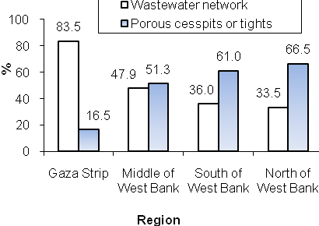

More than two-thirds of economic establishments used the wastewater network

Data for 2015 indicated that 71.3% of economic establishments in Palestine used the wastewater network to dispose of their wastewater and 15.2% used porous cesspits.

More than half of schools were not connected to wastewater networks

Data revealed that 48.1% of schools in Palestine dispose of wastewater through the wastewater network while 39.4% use a porous cesspit. However 58.6% of kindergartens in Palestine dispose of wastewater through the wastewater network, while 90.5% of higher education establishments in Palestine dispose of wastewater through the wastewater network and 7.9% use a porous cesspit in 2016.

82 liter/capita/day Palestinian water consumption rate

The daily allocation per capita from consumed water for domestic purposes is 82.2 liter/capita/day in Palestine. 84.3 (l/c/d) in the West Bank, where it is 79.2 (l/c/d) in Gaza Strip in 2015.

More than 97% of the water pumped from the coastal aquifer does not meet the water quality standards of the World Health Organization

The amount of water extracted from the coastal aquifer for domestic use was 167.2 MCM in Gaza Strip in 2015, but this quantity is obtained via unsafe pumping that jeopardizes sustainability of the source knowing that the basin sustainable yield should not exceed 50-60 MCM a year. More than 97% of the water pumped from the coastal aquifer in Gaza Strip does not meet the water quality standards of the World Health Organization.

80% of Available Water is Ground Water

Data showed that the percentage of the exploitation of surface and ground water from available water in the year 2015 was high, with an average of 79.7%.

It should be noted that the Palestinians have been denied access to extraction from the Jordan River since 1967, which was estimated about 250 MCM.

On the other hand, the quantity of Water Pumped from Palestinian Wells in the West Bank in 2015 was 83.3 MCM from Eastern aquifer, Western aquifer and North-Eastern aquifer.

Percentage of abstracted surface and ground water from available water, 2009-2015
