Palestinian Central Bureau of Statistics (PCBS)

Preliminary Results of the Palestinian Registered* External Trade in Goods of
March, 03/2018.

Exports in Goods:
Exports decreased in March, 2018 by 1.3% compared to February, 2018. While it increased by 9.1% compared to March, 2017 and reached USD 94.6 Million.

Exports to Israel increased in March, 2018 by 11% compared to February, 2018 and it represented 89.4% of total exports in March, 2018.

On the other hand, exports to other countries decreased by 49% during the same period compared to February, 2018.

Imports in Goods:
Imports increased in March, 2018 by 6.8% compared to February, 2018. While it slightly decreased by 0.3% compared to March, 2017 and reached USD 464.8 Million.

Imports from Israel increased by 7.3% in March, 2018 compared to February, 2018 and it represented 58.5% of total imports in March, 2018.

At the same time, imports from other countries increased by 6% compared to February, 2018.

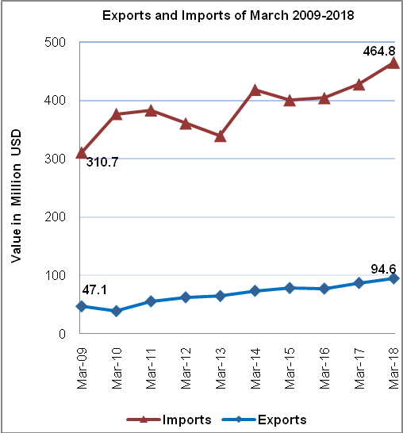

Net Trade Balance on Registered Goods:
The trade balance which represents the difference between exports and imports showed an increase in trade deficit by 9% in March, 2018 compared to February, 2018. While it decreased by 2.4% compared to March, 2017 and reached USD 370.2 Million.

Note:
*: Includes actual data received from official sources.

