Palestinian Central Bureau of Statistics (PCBS)

A decrease in Registered* Imports in Goods by 4% in May, 05/2019

Exports in Goods
Exports decreased in May, 2019 by 1% compared to April, 2019. It also decreased by 6% compared to May, 2018 and reached USD 89.7 Million.

Exports to Israel increased in May, 2019 by 4% compared to April, 2019 and it represented 91% of total exports in May, 2019.

On the other hand, exports to other countries decreased by 33% during the same period compared to April, 2019 and reached USD 8.1 Million.

Imports in Goods
Imports decreased in May, 2019 by 4% compared to April, 2019. It also decreased by 2% compared to May, 2018 and reached USD 483.3 Million.

Imports from Israel decreased by 6% in May, 2019 compared to April, 2019 and it represented 57% of total imports in May, 2019.

At the same time, imports from other countries decreased by 2% compared to April, 2019.

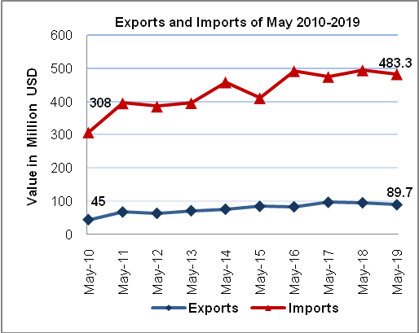
Trade Balance on Registered Goods
The trade balance which represents the difference between exports and imports showed a decrease in trade deficit by 5% in May, 2019 compared to April, 2019. It also decreased by 1% compared to May, 2018 and reached USD 393.6 Million.
(*): Includes actual data received from official sources.

Next release on: 22/08/2019

