Palestinian Central Bureau of Statistics (PCBS)

A decrease in registered* Exports and Imports in Goods by 2% and 8% respectively in February, 02/2021 compared to the previous month.

Exports in Goods
Exports decreased in February, 2021 by 2% compared to January, 2021. While it increased by 26% compared to February, 2020 and reached USD 99.9 Million.

Exports to Israel decreased in February, 2021 by 3% compared to January, 2021 and it represented 86% of total exports in February, 2021

On the other hand, exports to other countries increased by 4% during the same period compared to January, 2021.

Imports in Goods
Imports decreased in February, 2021 by 8% compared to January, 2021. While it increased by 7% compared to February, 2020 and reached USD 451.9 Million.

Imports from Israel decreased by 12% in February, 2021 compared to January, 2021 and it represented 55% of total imports in February, 2021.

At the same time, imports from other countries decreased by 3% compared to January, 2021.

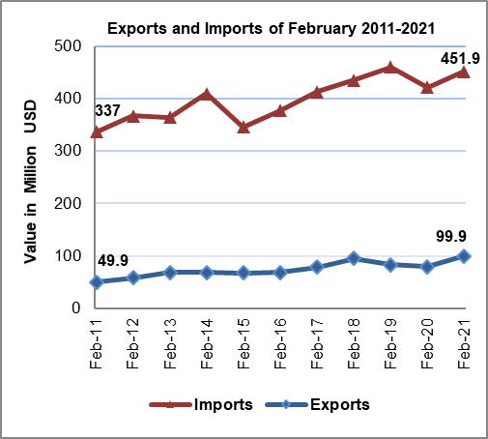
Trade Balance on Registered Goods
The trade balance which represents the difference between exports and imports showed a decrease in trade deficit by 10% in February, 2021 compared to January, 2021. While it increased by 3% compared to February, 2020 and reached USD 352 Million.

(*): Includes actual data received from official sources.

