Palestinian Central Bureau of Statistics (PCBS) Issues a Press Release on the Results of COVID-19 Business Pulse Survey in Palestine, 2020 during (5/3/2020 – 31/5/2020)

Ramallah, 20/04/2021 - The Palestinian Central Bureau of Statistics (PCBS) announced, in cooperation with GIZ, the results of the first round of the COVID-19 Business Pulse Survey in Palestine, 2020 via a virtual workshop launched today with the presence of H.E. Dr. Ola Awad, President of PCBS , Mrs. Hanna Ilge, Deputy Head of Cooperation at the Germany Representative Office and Ms. Heike Knoop, Head of Programme at GIZ, in addition to representatives from ministries, universities, research centers, private and public institutions, local partners, international organizations and media.
.
Dr. Ola Awad opened her speech extending her appreciation and gratitude to all partners who supported the implementation of this survey with its two phases:
- Phase one was implemented on a small sample of about (2,600) enterprises with a generous financial and technical support of the World Bank through the IPSD Project of the Ministry of National Economy.

- While phase two was implemented on a larger sample of about (14,000) enterprises to enable us disseminate data in more detailed levels through a financial and technical cooperation with GIZ.

The preliminary results of indicated that the Coronavirus pandemic made business establishments suffer from demand and supply shocks and financial shocks, which, in return, made establishments turn to take financial and administrative measures as well as digital solutions to face the impacts of the pandemic.

The main results of a survey on the impact of COVID-19 on business establishments during lockdown period (5/3/2020 – 31/5/2020):

More than two thirds of the establishments were closed for about one month and a half during lockdown period (5/3/2020 – 31/5/2020), where closure centered in the sector of services in Bethlehem Governorate; thus, 62% of establishments suffered from decreasing in supplies related to production inputs such as raw materials and production requirements. In addition, there was a decline of about the half in the production level or the size of sales, where 14% of Palestinian establishments had to let part of their employees go, in order to face this crisis.

75% of the establishments were closed for various periods
Results indicated that 75% of establishments (93% in the West Bank and 37% in Gaza Strip) were closed for many days due to the restriction measures taken by the government enforcing the necessity of closure as a preventative measure for fighting the Coronavirus outbreak.
The percentage of the closure days during the lockdown period (5/3/2020 – 31/5/2020) was (50%) concentrated in services activity, where the percentage of closure days for this activity reached (64%) and it reached (55%) for the industry activity. While the percentage of closure days for the activities of transport and trade reached (53%) and (42%), respectively. In addition, the biggest percentage of closure was centered in Bethlehem Governorate for a period of more than two months.

Demand Shocks: (An average sales/production decline by 50% compared with normal situation)

Most of the establishments reported that sales/production size has decreased during the three months of the lockdown by (94%), with a decline in the average sales/production by 53% compared with normal situation, where establishments operating in construction sector recorded the highest decline of the average sales/production by (63%), followed by establishments operating in the transportation sector with a decline of (60%).

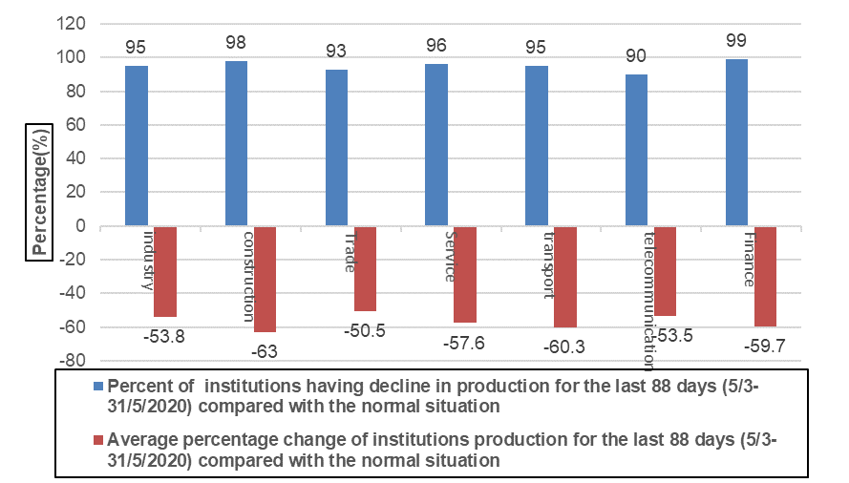

Supply Shocks: (62% of establishments reported having difficulties in the supply of inputs and raw materials)

62% of the establishments reported having difficulties in the supply of inputs, raw materials or finished goods and purchased materials (68% in the West Bank and 51% in Gaza Strip). Hence, economic activities suffering the most from this difficulty were industry sector with a percentage of (69%), trade sector at (68%) and construction sector at (68%).

Financial shock: (89% of the establishments are facing a decline in the availability of cash flow)
89% of the establishments are facing a decline in the availability of cash flow, which affected the percentage of returned checks that increased to reach 37% (49% in the West Bank and 11% in Gaza Strip). Also, 59% of the establishments reported having a difficulty in the provision of financial services that are usually available in the normal situation.
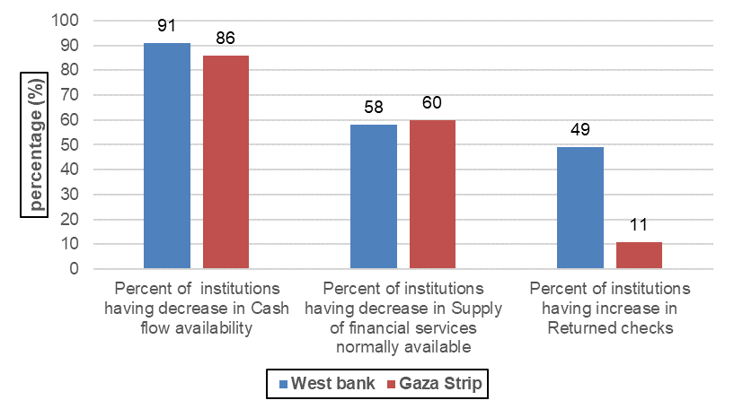
Financial Adjustment Mechanism: (39% of the establishments had to have delay payments to suppliers and employees to face shortage in cash flow)

39% of establishments had to have delay payments to suppliers and employees, whereas 36% of them had to get loans from friends, family, relatives to cover the shortage in cash flow.

Impact on employment: (14% of establishments had to let their employees go in order to face the financial crisis)

As a response to COVID-19 pandemic, 14% of the establishments had to dismiss and let go their employees to face the financial crisis resulted from the Coronavirus pandemic.
Whereas 8% of the establishments reduced the salaries and wages of their employees, and 11% of them gave their employees unpaid leave while 9% of them gave their employees a paid leave.

Use of Digital Solutions: (13% of the establishments started using or have increased the use of digital solutions as a response to COVID-19 outbreak)

13% of the establishments started using or have increased the use of internet, online social media networks, specialized apps or digital platforms in response to COVID-19 outbreak; whereas the main use of such digital solutions was for marketing with a percentage of 69%, 53% for business administration and 40% for service delivery. According to the results of the survey, there is a direction by the government to turn into digital economy, where MONE managed to make its services available online to ensure the fulfillment of transactions, especially import and export operations. Moreover, there are relentless efforts made by MONE to provide technical support for establishments for training them on the requirements of shifting to online services and qualify staffs to face the emerging needs.

During the last three months (88 days) starting from March 5th until May 31st, 2020), establishments reported that the percentage of employees who are currently working remotely from home was 6% of the total number of employees; mainly in the telecommunication sector (18% of the total number of employees) and construction sector (8% of the total number of employees). The main results also showed that the highest percentage of employees who were working remotely from home was among large establishments with a percentage of (12%).

Needed policies: (72% of establishments chose utility subsidies as the most needed policies to support their businesses)
69% of the establishments chose utility subsidies such as electricity, water, wastewater, internet services, and others, as the most needed policies to support their businesses over COVID-19 crisis. While 55% of the establishments chose exemptions or tax deductions, followed by salary subsidies with 51% and 49% for rental deferral.

Future vision: (47% of the establishments expect a decline in production for the next 3 months compared to the same period last year)
The expected percentage change in production for the next three months* that establishments anticipated to be was a decline by 47% compared to the same period last year. As for the number of employees, they expected that it would decline by 23%.

Note:
* The next three months are the months following the lockdown period after 31/5/2020.

